Figure 7
Connections over 200 kbps in at Least One Direction 2010-2014
(In thousands)

 | 2010 | 2011 |  | 2012 |  | 2013 |  | 2014
Technology | Dec | Jun | Dec | Jun | Dec | Jun | Dec | Jun* | Dec
Total | 182,065 | 206,131 | 230,201 | 243,359 | 262,564 | 284,692 | 293,397 | 311,284 | 321,305
Total Fixed | 84,521 | 86,575 | 88,317 | 89,945 | 92,511 | 93,986 | 96,032 | 95,998 | 97,810
Mobile Wireless | 97,544 | 119,556 | 141,883 | 153,414 | 170,053 | 190,706 | 197,365 | 215,286 | 223,495

Figure 8
Residential Connections over 200 kbps in at Least One Direction 2010-2014
(In thousands)

 | 2010 | 2011 |  | 2012 |  | 2013 |  | 2014
Technology | Dec | Jun | Dec | Jun | Dec | Jun | Dec | Jun* | Dec
Total | 149,441 | 171,773 | 186,516 | 196,665 | 215,817 | 235,273 | 246,797 | 264,343 | 273,950
Total Fixed | 76,918 | 78,906 | 80,706 | 82,217 | 84,392 | 85,277 | 87,599 | 87,360 | 89,196
Mobile Wireless | 72,523 | 92,867 | 105,810 | 114,448 | 131,425 | 149,996 | 159,197 | 176,983 | 184,754

* The June 2014 data have not been subjected to the typical quality checks.

The Commission approved changes to the Form 477 in June 2013 that affect the data beginning in June 2014 (see pages 1-2). Some previously-published data may
have been revised. Figures may not sum to totals elsewhere in this report due to rounding.

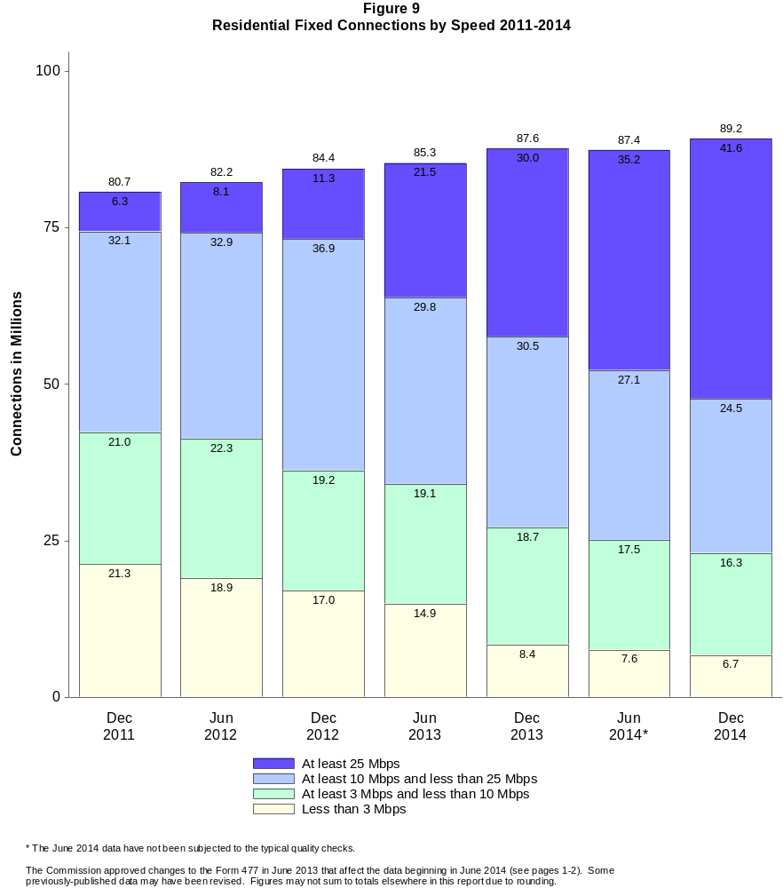

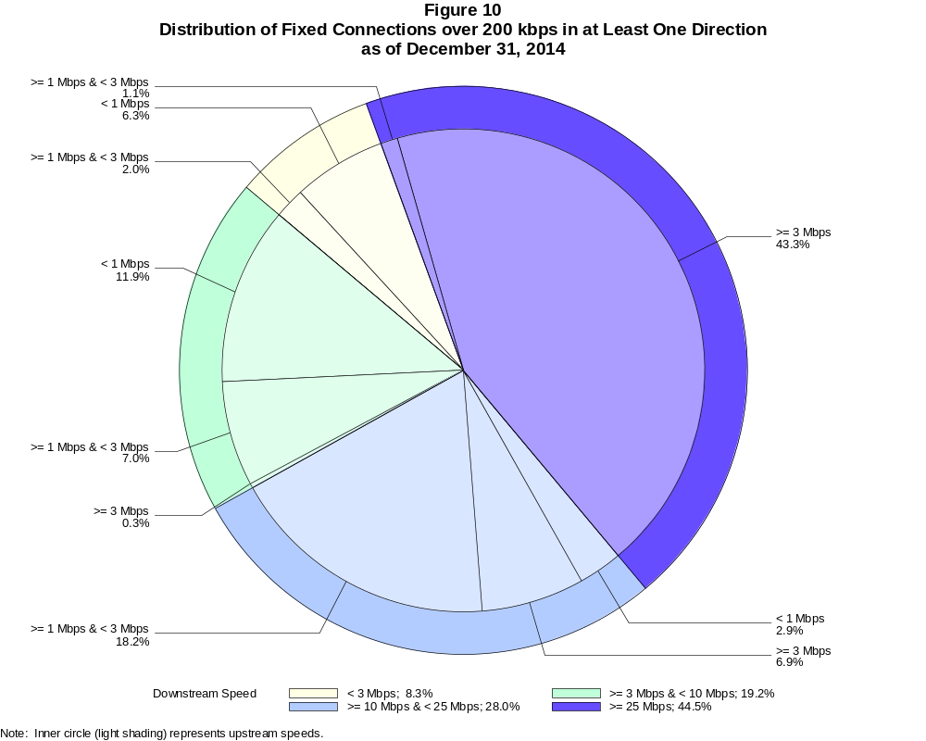

Fixed Connections over 200 kbps in at Least One Direction (in thousands)

 | Downstream Speed
Upstream Speed | Less than 3 Mbps | At least 3 Mbps  and less than 10 Mbps | At least 10 Mbps  and less than 25 Mbps | At least 25 Mbps | Total
Less than 1 Mbps | 6,121 | 11,631 | 2,877 | 2 | 20,631
At least 1 Mbps & Less than 3 Mbps | 1,988 | 6,878 | 17,761 | 1,109 | 27,736
At least 3 Mbps | 7 | 298 | 6,748 | 42,390 | 49,443
Total | 8,116 | 18,806 | 27,386 | 43,502 | 97,810

Percentages

Less than 1 Mbps | 6.3 | 11.9 | 2.9 | 0.0 | 21.1
At least 1 Mbps & Less than 3 Mbps | 2.0 | 7.0 | 18.2 | 1.1 | 28.4
At least 3 Mbps | 0.0 | 0.3 | 6.9 | 43.3 | 50.6
Total | 8.3 | 19.2 | 28.0 | 44.5 | 100.0

Note: Figures may not sum to totals due to rounding.
Source: FCC Form 477.

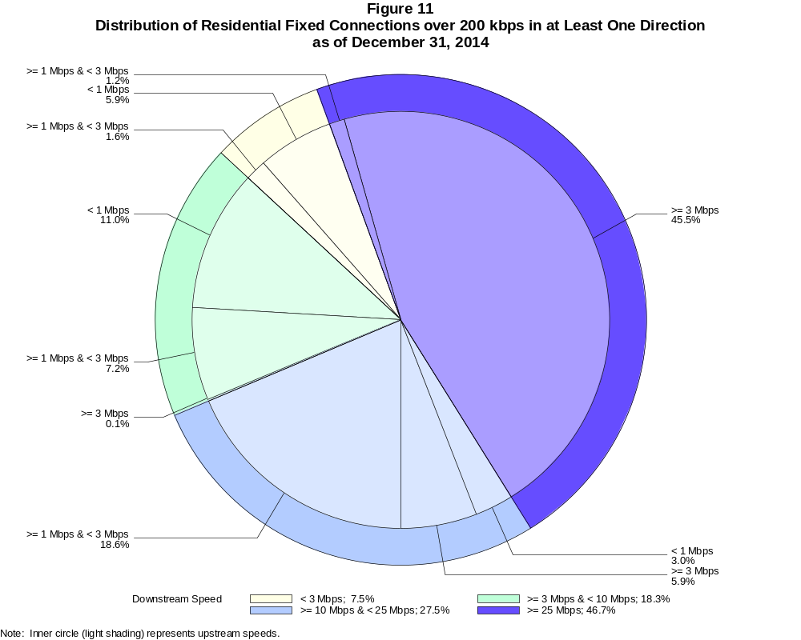

Residential Fixed Connections over 200 kbps in at Least One Direction (in thousands)

 | Downstream Speed
Upstream Speed | Less than 3 Mbps | At least 3 Mbps  and less than 10 Mbps | At least 10 Mbps  and less than 25 Mbps | At least 25 Mbps | Total
Less than 1 Mbps | 5,254 | 9,788 | 2,654 | 2 | 17,698
At least 1 Mbps & Less than 3 Mbps | 1,450 | 6,399 | 16,600 | 1,048 | 25,497
At least 3 Mbps | 6 | 122 | 5,279 | 40,595 | 46,002
Total | 6,710 | 16,308 | 24,533 | 41,645 | 89,196

Percentages

Less than 1 Mbps | 5.9 | 11.0 | 3.0 | 0.0 | 19.8
At least 1 Mbps & Less than 3 Mbps | 1.6 | 7.2 | 18.6 | 1.2 | 28.6
At least 3 Mbps | 0.0 | 0.1 | 5.9 | 45.5 | 51.6
Total | 7.5 | 18.3 | 27.5 | 46.7 | 100.0

Note: Figures may not sum to totals due to rounding.
Source: FCC Form 477.

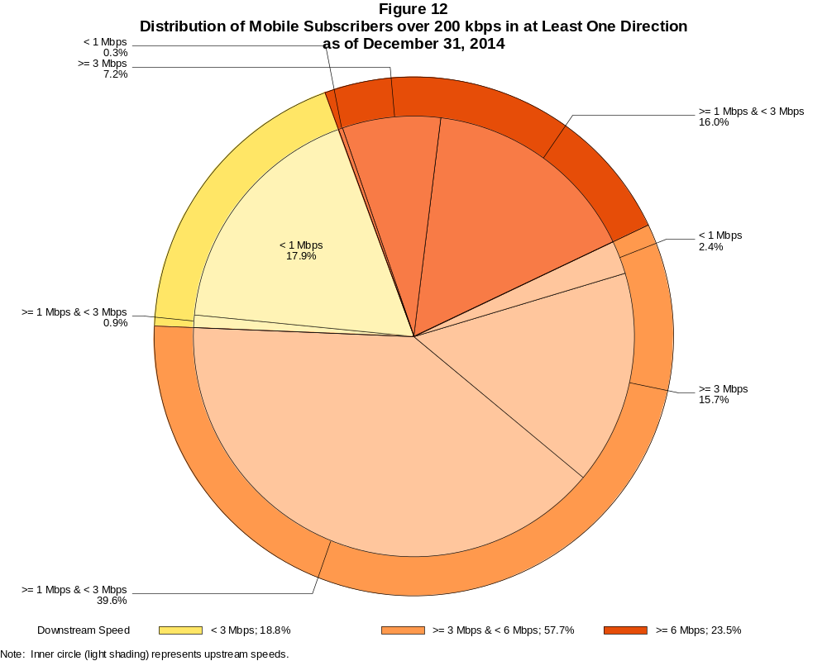

Mobile Subscribers over 200 kbps in at Least One Direction (in thousands)

 | Downstream Speed
Upstream Speed | Less than 3 Mbps | At least 3 Mbps  and less than 6 Mbps | At least 6 Mbps | Total
Less than 1 Mbps | 39,986 | 5,468 | 688 | 46,142
At least 1 Mbps & Less than 3 Mbps | 2,040 | 88,446 | 35,709 | 126,195
At least 3 Mbps | 1 | 35,067 | 16,090 | 51,158
Total | 42,027 | 128,981 | 52,487 | 223,495

Percentages

Less than 1 Mbps | 17.9 | 2.4 | 0.3 | 20.6
At least 1 Mbps & Less than 3 Mbps | 0.9 | 39.6 | 16.0 | 56.5
At least 3 Mbps | 0.0 | 15.7 | 7.2 | 22.9
Total | 18.8 | 57.7 | 23.5 | 100.0

Note: Figures may not sum to totals due to rounding.
Source: FCC Form 477.

Figure 13
Connections over 200 kbps in at Least One Direction by Technology 2010-2014
(In thousands)

 | 2010 | 2011 |  | 2012 |  | 2013 |  | 2014
Technology | Dec | Jun | Dec | Jun | Dec | Jun | Dec | Jun* | Dec
Total | 182,065 | 206,131 | 230,201 | 243,359 | 262,564 | 284,692 | 293,397 | 311,284 | 321,305
Total Fixed | 84,521 | 86,575 | 88,317 | 89,945 | 92,511 | 93,986 | 96,032 | 95,998 | 97,810
aDSL | 31,470 | 31,611 | 31,330 | 31,173 | 30,974 | 30,657 | 30,690 | 29,873 | 28,527
sDSL | 167 | 159 | 148 | 139 | 132 | 117 | 108 | 96 | 85
Other Wireline¹ | 795 | 778 | 795 | 770 | 796 | 769 | 772 | 792 | 723
Cable Modem | 45,334 | 46,698 | 48,263 | 49,664 | 51,646 | 52,760 | 54,009 | 54,011 | 56,301
FTTP² | 4,993 | 5,477 | 5,898 | 6,300 | 6,733 | 7,250 | 7,745 | 8,326 | 9,180
Satellite | 1,176 | 1,204 | 1,190 | 1,217 | 1,454 | 1,623 | 1,849 | 1,964 | 2,006
Fixed Wireless | 587 | 649 | 693 | 682 | 777 | 810 | 858 | 935 | 988
Mobile Wireless | 97,544 | 119,556 | 141,883 | 153,414 | 170,053 | 190,706 | 197,365 | 215,286 | 223,495

¹ Power Line and Other are summarized with Other Wireline to maintain firm confidentiality. No Power Line connections were reported after 2012. See Technical
Notes at the end of the report for a description of Form 477 technology categories and other reporting requirements.
² Fiber to the premises.
* The June 2014 data have not been subjected to the typical quality checks.

The Commission approved changes to the Form 477 in June 2013 that affect the data beginning in June 2014 (see pages 1-2). Some previously-published data may
have been revised. Figures may not sum to totals due to rounding.

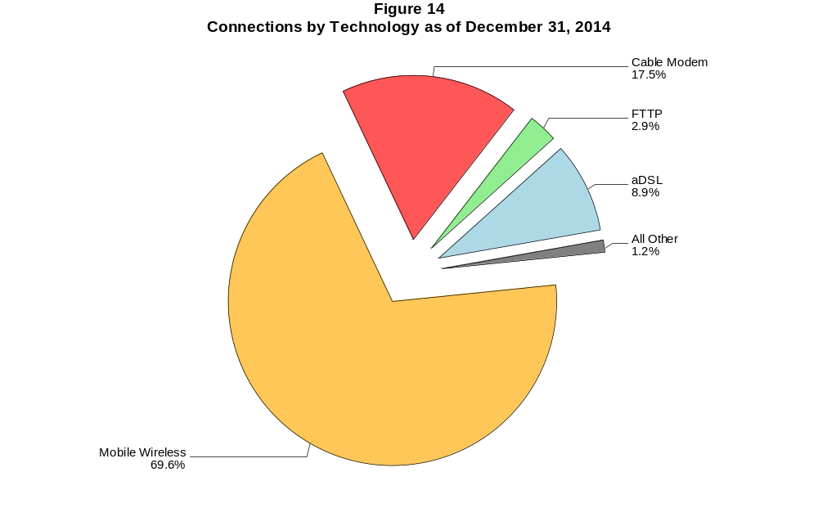

Figure 15
Residential Connections over 200 kbps in at Least One Direction by Technology 2010-2014
(In thousands)

 | 2010 | 2011 |  | 2012 |  | 2013 |  | 2014
Technology | Dec | Jun | Dec | Jun | Dec | Jun | Dec | Jun* | Dec
Total | 149,441 | 171,773 | 186,516 | 196,665 | 215,817 | 235,273 | 246,797 | 264,343 | 273,950
Total Fixed | 76,918 | 78,906 | 80,706 | 82,217 | 84,392 | 85,277 | 87,599 | 87,360 | 89,196
aDSL | 27,467 | 27,754 | 27,758 | 27,632 | 27,391 | 26,869 | 27,248 | 26,678 | 25,603
sDSL | 53 | 52 | 54 | 49 | 50 | 43 | 39 | 30 | 22
Other Wireline¹ | 76 | 45 | 40 | 14 | 34 | 22 | 22 | 57 | 59
Cable Modem | 43,295 | 44,480 | 45,832 | 47,033 | 48,716 | 49,494 | 50,709 | 50,389 | 52,467
FTTP² | 4,704 | 5,118 | 5,521 | 5,892 | 6,270 | 6,732 | 7,176 | 7,617 | 8,368
Satellite | 811 | 885 | 886 | 998 | 1,242 | 1,407 | 1,643 | 1,760 | 1,803
Fixed Wireless | 513 | 572 | 616 | 600 | 689 | 710 | 763 | 829 | 874
Mobile Wireless | 72,523 | 92,867 | 105,810 | 114,448 | 131,425 | 149,996 | 159,197 | 176,983 | 184,754

¹ Power Line and Other are summarized with Other Wireline to maintain firm confidentiality. No Power Line connections were reported after 2012. See Technical
Notes at the end of the report for a description of Form 477 technology categories and other reporting requirements.
² Fiber to the premises.
* The June 2014 data have not been subjected to the typical quality checks.

The Commission approved changes to the Form 477 in June 2013 that affect the data beginning in June 2014 (see pages 1-2). Some previously-published data may
have been revised. Figures may not sum to totals due to rounding.

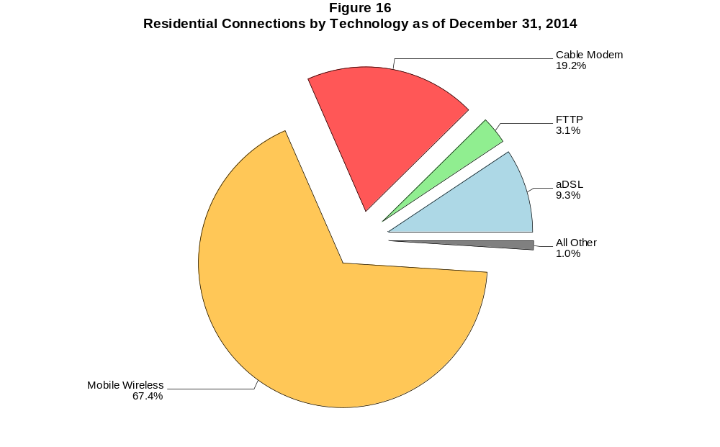

Figure 17
Fixed Connections at Least 3 Mbps Downstream and 768 kbps Upstream by Technology 2010-2014
(In thousands)

 | 2010 | 2011 |  | 2012 |  | 2013 |  | 2014
Technology | Dec | Jun | Dec | Jun | Dec | Jun | Dec | Jun* | Dec
Total | 44,694 | 48,577 | 51,097 | 57,243 | 64,657 | 68,673 | 78,175 | 78,981 | 83,872
aDSL | 7,302 | 8,909 | 10,351 | 12,875 | 13,108 | 14,233 | 18,540 | 17,246 | 18,557
sDSL | 14 | 16 | 26 | 30 | 33 | 34 | 36 | 33 | 28
Other Wireline¹ | 211 | 204 | 228 | 239 | 276 | 284 | 308 | 310 | 308
Cable Modem | 32,338 | 34,113 | 34,699 | 37,798 | 44,133 | 46,014 | 50,236 | 51,304 | 53,853
FTTP² | 4,725 | 5,188 | 5,606 | 6,001 | 6,430 | 6,981 | 7,486 | 8,111 | 8,974
Satellite | # | # | # | 87 | 394 | 791 | 1,181 | 1,424 | 1,558
Fixed Wireless | 105 | 145 | 186 | 214 | 284 | 337 | 388 | 553 | 594

¹ Power Line and Other are summarized with Other Wireline to maintain firm confidentiality. No Power Line connections were reported after 2012. See Technical
Notes at the end of the report for a description of Form 477 technology categories and other reporting requirements.
² Fiber to the premises.
* The June 2014 data have not been subjected to the typical quality checks.
# = Rounds to zero.

The Commission approved changes to the Form 477 in June 2013 that affect the data beginning in June 2014 (see pages 1-2). Some previously-published data may
have been revised. Figures may not sum to totals due to rounding.

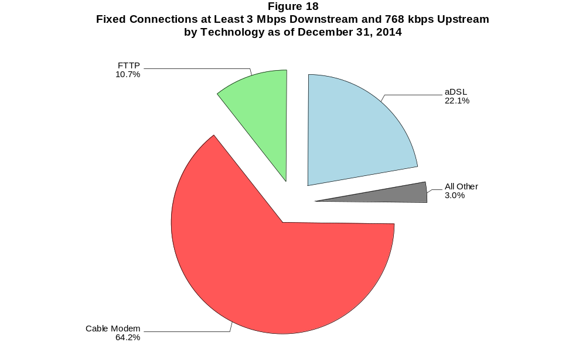

Figure 19
Residential Fixed Connections at Least 3 Mbps Downstream and 768 kbps Upstream by Technology 2010-2014
(In thousands)

 | 2010 | 2011 |  | 2012 |  | 2013 |  | 2014
Technology | Dec | Jun | Dec | Jun | Dec | Jun | Dec | Jun* | Dec
Total | 41,769 | 45,263 | 47,427 | 53,070 | 59,914 | 63,342 | 72,476 | 73,042 | 77,540
aDSL | 6,421 | 7,909 | 9,274 | 11,563 | 11,669 | 12,666 | 16,715 | 15,673 | 16,867
sDSL | 2 | 4 | 12 | 12 | 13 | 13 | 13 | 7 | 2
Other Wireline¹ | 36 | 15 | 16 | 7 | 20 | 21 | 20 | 45 | 50
Cable Modem | 30,742 | 32,321 | 32,693 | 35,583 | 41,561 | 43,061 | 47,258 | 47,924 | 50,308
FTTP² | 4,482 | 4,894 | 5,271 | 5,632 | 6,012 | 6,504 | 6,958 | 7,491 | 8,246
Satellite | 0 | 0 | # | 86 | 393 | 788 | 1,177 | 1,419 | 1,552
Fixed Wireless | 86 | 121 | 161 | 185 | 245 | 289 | 335 | 483 | 516

¹ Power Line and Other are summarized with Other Wireline to maintain firm confidentiality. No Power Line connections were reported after 2012. See Technical
Notes at the end of the report for a description of Form 477 technology categories and other reporting requirements.
² Fiber to the premises.
* The June 2014 data have not been subjected to the typical quality checks.
# = Rounds to zero.

The Commission approved changes to the Form 477 in June 2013 that affect the data beginning in June 2014 (see pages 1-2). Some previously-published data may
have been revised. Figures may not sum to totals due to rounding.

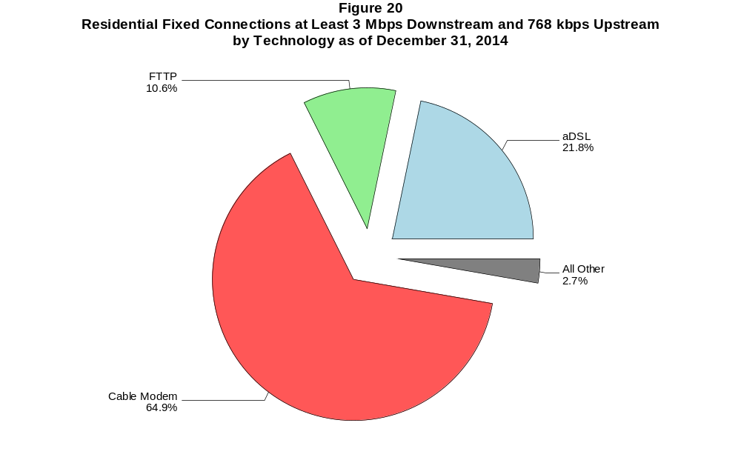

Figure 21
Fixed Connections at Least 10 Mbps Downstream and 1 Mbps Upstream by Technology in 2014
(In thousands)

 | 2014
Technology | Jun* | Dec
Total | 63,849 | 68,009
aDSL | 7,573 | 8,310
sDSL | 9 | 6
Other Wireline¹ | 169 | 183
Cable Modem | 47,296 | 49,839
FTTP² | 7,615 | 8,341
Satellite | 1,016 | 1,137
Fixed Wireless | 170 | 192

¹ Power Line and Other are summarized with Other Wireline to maintain firm confidentiality. See Technical Notes at the end of the report for a description of
Form 477 technology categories and other reporting requirements.
² Fiber to the premises.
* The June 2014 data have not been subjected to the typical quality checks.
# = Rounds to zero.

The Commission approved changes to the Form 477 in June 2013 that affect the data beginning in June 2014 (see pages 1-2).
Figures may not sum to totals due to rounding.

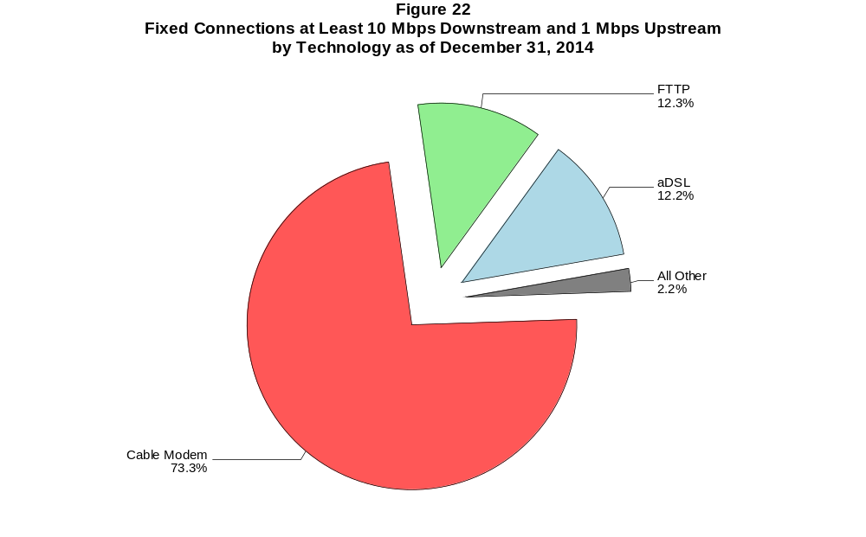

Figure 23
Residential Fixed Connections at Least 10 Mbps Downstream and 1 Mbps Upstream by Technology in 2014
(In thousands)

 | 2014
Technology | Jun* | Dec
Total | 59,751 | 63,522
aDSL | 7,035 | 7,741
sDSL | 3 | #
Other Wireline¹ | 33 | 36
Cable Modem | 44,480 | 46,767
FTTP² | 7,044 | 7,679
Satellite | 1,014 | 1,133
Fixed Wireless | 142 | 166

¹ Power Line and Other are summarized with Other Wireline to maintain firm confidentiality. See Technical Notes at the end of the report for a description of
Form 477 technology categories and other reporting requirements.
² Fiber to the premises.
* The June 2014 data have not been subjected to the typical quality checks.
# = Rounds to zero.

The Commission approved changes to the Form 477 in June 2013 that affect the data beginning in June 2014 (see pages 1-2).
Figures may not sum to totals due to rounding.

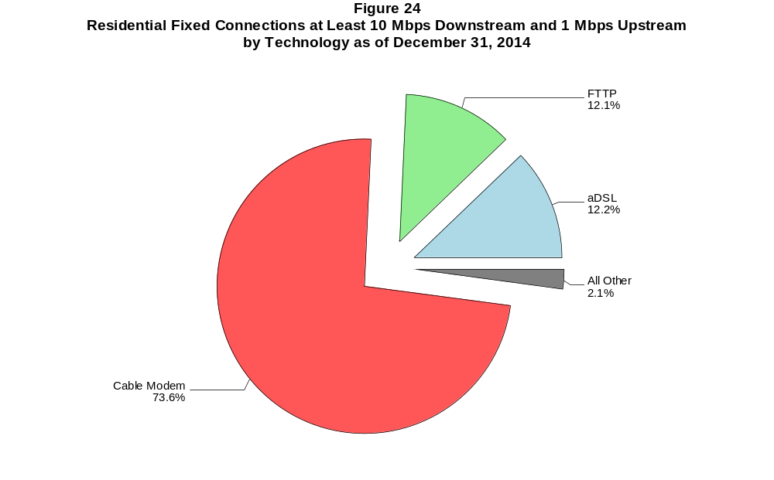

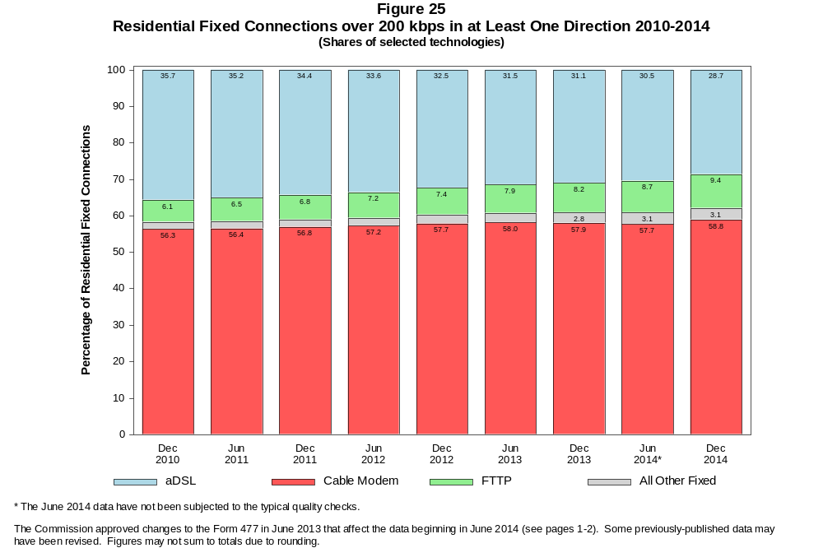

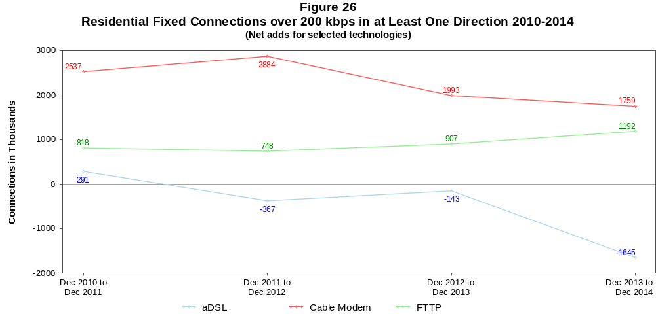

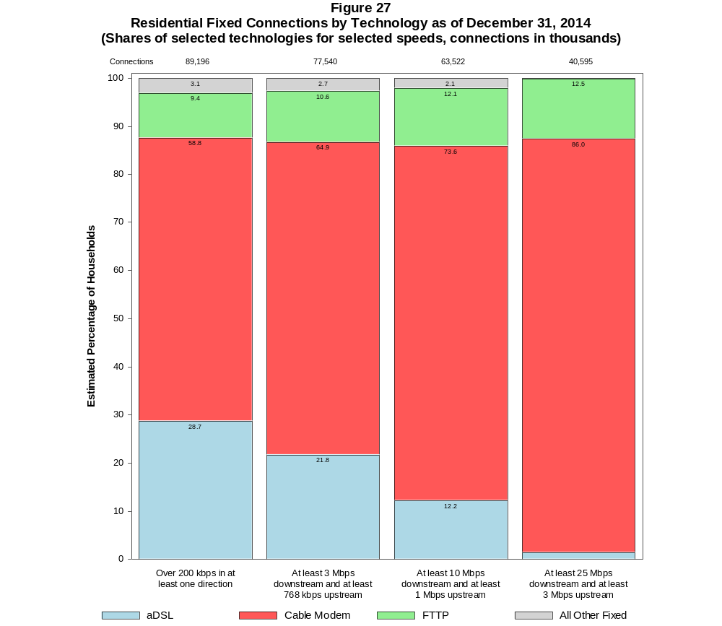

Figure 28
Fixed Connections by Downstream Speed Tier and Technology as of December 31, 2014
(In thousands)

 | Downstream Speed
Technology | Less than  1.5 Mbps | At least 1.5 Mbps  and less than  3 Mbps | At least 3 Mbps  and less than  10 Mbps | At least 10 Mbps  and less than  25 Mbps | At least 25 Mbps  and less than  100 Mbps | At least 100 Mbps | Total
aDSL | 2,027 | 3,211 | 12,401 | 10,215 | 665 | 8 | 28,527
sDSL | 37 | 20 | 21 | 5 | * | * | 85
Other Wireline | 56 | 354 | 130 | 58 | 28 | 98 | 723
Cable Modem | 547 | 946 | 4,775 | 12,947 | 28,079 | 9,008 | 56,301
FTTP | 62 | 95 | 577 | 2,860 | 5,196 | 390 | 9,180
Satellite | 354 | 60 | 455 | 1,136 | * | * | 2,006
Fixed Wireless | 158 | 189 | 447 | 165 | 19 | 9 | 988
Total | 3,240 | 4,876 | 18,806 | 27,386 | 33,988 | 9,514 | 97,810

Percentages

aDSL | 2.1 | 3.3 | 12.7 | 10.4 | 0.7 | 0.0 | 29.2
sDSL | 0.0 | 0.0 | 0.0 | 0.0 | * | * | 0.1
Other Wireline | 0.1 | 0.4 | 0.1 | 0.1 | 0.0 | 0.1 | 0.7
Cable Modem | 0.6 | 1.0 | 4.9 | 13.2 | 28.7 | 9.2 | 57.6
FTTP | 0.1 | 0.1 | 0.6 | 2.9 | 5.3 | 0.4 | 9.4
Satellite | 0.4 | 0.1 | 0.5 | 1.2 | * | * | 2.1
Fixed Wireless | 0.2 | 0.2 | 0.5 | 0.2 | 0.0 | 0.0 | 1.0
Total | 3.3 | 5.0 | 19.2 | 28.0 | 34.7 | 9.7 | 100.0

# = Rounds to Zero.
* = Data withheld to maintain firm confidentiality.
Note: Figures may not sum to totals due to rounding.
Source: FCC Form 477.

Figure 29
Residential Fixed Connections by Downstream Speed Tier and Technology as of December 31, 2014
(In thousands)

 | Downstream Speed
Technology | Less than  1.5 Mbps | At least 1.5 Mbps  and less than  3 Mbps | At least 3 Mbps  and less than  10 Mbps | At least 10 Mbps  and less than  25 Mbps | At least 25 Mbps  and less than  100 Mbps | At least 100 Mbps | Total
aDSL | 1,912 | 2,774 | 10,762 | 9,527 | 622 | 6 | 25,603
sDSL | 17 | 3 | 1 | # | * | * | 22
Other Wireline | 2 | 3 | 18 | 11 | 8 | 18 | 59
Cable Modem | 532 | 854 | 4,177 | 11,041 | 27,010 | 8,854 | 52,467
FTTP | 28 | 49 | 508 | 2,676 | 4,852 | 255 | 8,368
Satellite | 187 | 34 | 450 | 1,133 | * | * | 1,803
Fixed Wireless | 141 | 173 | 392 | 146 | 17 | 6 | 874
Total | 2,820 | 3,890 | 16,308 | 24,533 | 32,508 | 9,137 | 89,196

Percentages

aDSL | 2.1 | 3.1 | 12.1 | 10.7 | 0.7 | 0.0 | 28.7
sDSL | 0.0 | 0.0 | 0.0 | 0.0 | * | * | 0.0
Other Wireline | 0.0 | 0.0 | 0.0 | 0.0 | 0.0 | 0.0 | 0.1
Cable Modem | 0.6 | 1.0 | 4.7 | 12.4 | 30.3 | 9.9 | 58.8
FTTP | 0.0 | 0.1 | 0.6 | 3.0 | 5.4 | 0.3 | 9.4
Satellite | 0.2 | 0.0 | 0.5 | 1.3 | * | * | 2.0
Fixed Wireless | 0.2 | 0.2 | 0.4 | 0.2 | 0.0 | 0.0 | 1.0
Total | 3.2 | 4.4 | 18.3 | 27.5 | 36.4 | 10.2 | 100.0

# = Rounds to Zero.
* = Data withheld to maintain firm confidentiality.
Note: Figures may not sum to totals due to rounding.
Source: FCC Form 477.

Figure 30
Nationwide Number of Providers of Connections over 200 kbps in at Least One Direction
by Technology 2010-2014

 | 2010 | 2011 |  | 2012 |  | 2013 |  | 2014
Technology | Dec | Jun | Dec | Jun | Dec | Jun | Dec | Jun+ | Dec
aDSL | 865 | 867 | 867 | 860 | 865 | 852 | 851 | 794 | 792
sDSL | 247 | 252 | 255 | 251 | 255 | 246 | 239 | 195 | 191
Other Wireline | 270 | 265 | 274 | 258 | 262 | 246 | 245 | 241 | 238
Cable Modem | 357 | 400 | 405 | 401 | 404 | 403 | 407 | 394 | 402
FTTP | 545 | 579 | 621 | 642 | 666 | 692 | 744 | 879 | 906
Satellite | 4 | 5 | 6 | 5 | 6 | 5 | 5 | 18 | 16
Fixed Wireless | 646 | 672 | 713 | 713 | 765 | 771 | 825 | 871 | 916
Mobile Wireless | 57 | 64 | 69 | 67 | 70 | 79 | 77 | 91 | 98
Power Line and Other | 7 | 4 | 5 | * | * | 0 | * | 34 | 11
Total | 1,566 | 1,624 | 1,687 | 1,673 | 1,722 | 1,714 | 1,773 | 1,793 | 1,845

Multiple Form 477 filers within a holding company structure count as one provider. * = 1-3 providers.
+ The June 2014 data have not been subjected to the typical quality checks.

The Commission approved changes to the Form 477 in June 2013 that affect the data beginning in June 2014 (see pages 1-2). Some previously-published data may
have been revised.

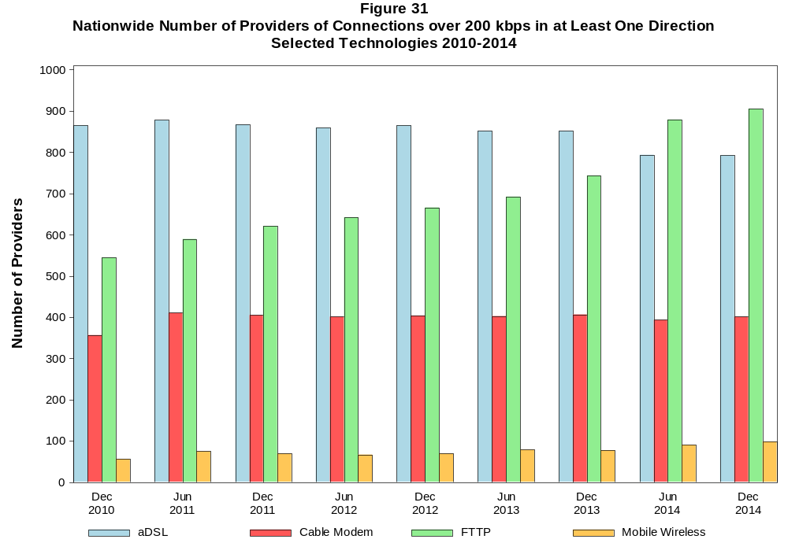

Figure 32
Residential Fixed Connections and Households by State as of December 31, 2014
(Connections and households, in thousands)
 |  | At least 3 Mbps Down  and 0.768 kbps Up |  | At least 10 Mbps Down  and 1 Mbps Up |  | At least 25 Mbps Down  and 3 Mbps Up
State | Households | Connections | Subscribership  Ratio | Connections | Subscribership  Ratio | Connections | Subscribership  Ratio
Alabama | 1,842 | 938 | 0.51 | 767 | 0.42 | 393 | 0.21
Alaska | 252 | 149 | 0.59 | 119 | 0.47 | 6 | 0.02
American Samoa | 10 | 0 | 0.00 | 0 | 0.00 | 0 | 0.00
Arizona | 2,387 | 1,693 | 0.71 | 1,080 | 0.45 | 1,008 | 0.42
Arkansas | 1,132 | 524 | 0.46 | 374 | 0.33 | 208 | 0.18
California | 12,617 | 9,338 | 0.74 | 7,793 | 0.62 | 5,323 | 0.42
Colorado | 1,998 | 1,541 | 0.77 | 1,040 | 0.52 | 979 | 0.49
Connecticut | 1,356 | 985 | 0.73 | 885 | 0.65 | 587 | 0.43
Delaware | 339 | 286 | 0.84 | 265 | 0.78 | * | *
District of Columbia | 267 | 205 | 0.77 | 176 | 0.66 | * | *
Florida | 7,218 | 5,651 | 0.78 | 4,776 | 0.66 | 2,681 | 0.37
Georgia | 3,541 | 2,188 | 0.62 | 1,754 | 0.50 | 1,195 | 0.34
Guam | 42 | * | * | * | * | * | *
Hawaii | 450 | 364 | 0.81 | 289 | 0.64 | * | *
Idaho | 585 | 331 | 0.57 | 181 | 0.31 | 128 | 0.22
Illinois | 4,779 | 3,042 | 0.64 | 2,538 | 0.53 | 1,773 | 0.37
Indiana | 2,492 | 1,376 | 0.55 | 1,119 | 0.45 | 635 | 0.25
Iowa | 1,232 | 669 | 0.54 | 426 | 0.35 | 61 | 0.05
Kansas | 1,112 | 659 | 0.59 | 486 | 0.44 | 249 | 0.22
Kentucky | 1,702 | 863 | 0.51 | 643 | 0.38 | 125 | 0.07
Louisiana | 1,719 | 899 | 0.52 | 725 | 0.42 | 515 | 0.30
Maine | 553 | 370 | 0.67 | 265 | 0.48 | 65 | 0.12
Maryland | 2,156 | 1,680 | 0.78 | 1,526 | 0.71 | 1,255 | 0.58
Massachusetts | 2,538 | 2,099 | 0.83 | 1,903 | 0.75 | 1,717 | 0.68
Michigan | 3,828 | 2,362 | 0.62 | 2,029 | 0.53 | 1,347 | 0.35
Minnesota | 2,115 | 1,312 | 0.62 | 961 | 0.45 | 791 | 0.37
Mississippi | 1,093 | 415 | 0.38 | 342 | 0.31 | 198 | 0.18
Missouri | 2,361 | 1,320 | 0.56 | 1,025 | 0.43 | 522 | 0.22
Montana | 408 | 224 | 0.55 | 151 | 0.37 | * | *
Nebraska | 731 | 460 | 0.63 | 297 | 0.41 | 211 | 0.29
Nevada | 1,006 | 686 | 0.68 | 472 | 0.47 | * | *
New Hampshire | 520 | 412 | 0.79 | 347 | 0.67 | 276 | 0.53
New Jersey | 3,188 | 2,703 | 0.85 | 2,523 | 0.79 | 1,845 | 0.58
New Mexico | 765 | 419 | 0.55 | 224 | 0.29 | 199 | 0.26
New York | 7,256 | 5,571 | 0.77 | 5,183 | 0.71 | 2,823 | 0.39
North Carolina | 3,743 | 2,192 | 0.59 | 1,764 | 0.47 | 605 | 0.16
North Dakota | 293 | 204 | 0.70 | 164 | 0.56 | 112 | 0.38
Northern Mariana Isl | 16 | * | * | 0 | 0.00 | 0 | 0.00
Ohio | 4,570 | 2,577 | 0.56 | 2,109 | 0.46 | 464 | 0.10
Oklahoma | 1,450 | 764 | 0.53 | 557 | 0.38 | 375 | 0.26
Oregon | 1,523 | 970 | 0.64 | 746 | 0.49 | 691 | 0.45
Pennsylvania | 4,958 | 3,284 | 0.66 | 2,617 | 0.53 | 2,211 | 0.45
Puerto Rico | 1,241 | 248 | 0.20 | * | * | 1 | 0.00
Rhode Island | 410 | 319 | 0.78 | 284 | 0.69 | * | *
South Carolina | 1,796 | 1,035 | 0.58 | 880 | 0.49 | 359 | 0.20
South Dakota | 327 | 218 | 0.67 | 160 | 0.49 | 120 | 0.37
Tennessee | 2,487 | 1,413 | 0.57 | 1,208 | 0.49 | 909 | 0.37
Texas | 9,014 | 5,790 | 0.64 | 4,784 | 0.53 | 2,178 | 0.24
Utah | 896 | 660 | 0.74 | 424 | 0.47 | 364 | 0.41
Vermont | 257 | 192 | 0.75 | 135 | 0.53 | 109 | 0.42
Virgin Islands | 43 | 5 | 0.12 | * | * | * | *
Virginia | 3,042 | 2,195 | 0.72 | 1,843 | 0.61 | 1,519 | 0.50
Washington | 2,645 | 1,883 | 0.71 | 1,501 | 0.57 | 1,401 | 0.53
West Virginia | 742 | 338 | 0.46 | 296 | 0.40 | 252 | 0.34
Wisconsin | 2,293 | 1,350 | 0.59 | 1,108 | 0.48 | 484 | 0.21
Wyoming | 226 | 130 | 0.58 | 100 | 0.44 | 85 | 0.38
Total | 117,564 | 77,540 | 0.66 | 63,522 | 0.54 | 40,595 | 0.35

# = Rounds to Zero; * = Data withheld to maintain firm confidentiality.
Note: Figures may not sum to totals due to rounding.
Sources: FCC Form 477 (Connections); 2010-2014 ACS 5-year estimates; Census 2010.

Figure 33
Connections by Type of End User by State as of December 31, 2014
(Connections over 200 kbps in at least one direction, in thousands)

 | Connections |  | Percentages
State | Residential | Business | Residential | Business | Total
Alabama | 3,940 | 508 | 88.6 | 11.4 | 4,448
Alaska | 676 | 99 | 87.2 | 12.8 | 775
American Samoa | * | * | * | * | *
Arizona | 5,357 | 862 | 86.1 | 13.9 | 6,218
Arkansas | 2,453 | 333 | 88.0 | 12.0 | 2,787
California | 34,828 | 5,966 | 85.4 | 14.6 | 40,794
Colorado | 4,815 | 835 | 85.2 | 14.8 | 5,650
Connecticut | 3,309 | 596 | 84.7 | 15.3 | 3,905
Delaware | 862 | 142 | 85.8 | 14.2 | 1,004
District of Columbia | 744 | 428 | 63.5 | 36.5 | 1,172
Florida | 16,464 | 2,866 | 85.2 | 14.8 | 19,330
Georgia | 8,165 | 1,383 | 85.5 | 14.5 | 9,548
Guam | 98 | 25 | 79.9 | 20.1 | 122
Hawaii | 1,310 | 180 | 87.9 | 12.1 | 1,490
Idaho | 1,308 | 214 | 85.9 | 14.1 | 1,522
Illinois | 11,150 | 2,000 | 84.8 | 15.2 | 13,151
Indiana | 5,397 | 770 | 87.5 | 12.5 | 6,166
Iowa | 2,599 | 426 | 85.9 | 14.1 | 3,024
Kansas | 2,316 | 438 | 84.1 | 15.9 | 2,754
Kentucky | 3,966 | 535 | 88.1 | 11.9 | 4,501
Louisiana | 4,160 | 569 | 88.0 | 12.0 | 4,729
Maine | 1,091 | 174 | 86.3 | 13.7 | 1,265
Maryland | 5,329 | 952 | 84.8 | 15.2 | 6,281
Massachusetts | 6,144 | 1,138 | 84.4 | 15.6 | 7,283
Michigan | 7,855 | 1,584 | 83.2 | 16.8 | 9,438
Minnesota | 4,573 | 882 | 83.8 | 16.2 | 5,456
Mississippi | 2,422 | 256 | 90.4 | 9.6 | 2,678
Missouri | 5,009 | 915 | 84.6 | 15.4 | 5,924
Montana | 850 | 117 | 87.9 | 12.1 | 966
Nebraska | 1,515 | 308 | 83.1 | 16.9 | 1,823
Nevada | 2,393 | 357 | 87.0 | 13.0 | 2,750
New Hampshire | 1,189 | 189 | 86.3 | 13.7 | 1,378
New Jersey | 8,491 | 1,585 | 84.3 | 15.7 | 10,076
New Mexico | 1,600 | 233 | 87.3 | 12.7 | 1,832
New York | 17,388 | 3,224 | 84.4 | 15.6 | 20,613
North Carolina | 7,971 | 1,358 | 85.4 | 14.6 | 9,329
North Dakota | 671 | 121 | 84.7 | 15.3 | 793
Northern Mariana Isl | * | * | * | * | *
Ohio | 9,730 | 1,680 | 85.3 | 14.7 | 11,410
Oklahoma | 3,270 | 506 | 86.6 | 13.4 | 3,776
Oregon | 3,396 | 578 | 85.4 | 14.6 | 3,974
Pennsylvania | 10,842 | 1,835 | 85.5 | 14.5 | 12,676
Puerto Rico | 2,587 | 193 | 93.1 | 6.9 | 2,780
Rhode Island | 904 | 156 | 85.3 | 14.7 | 1,061
South Carolina | 3,741 | 531 | 87.6 | 12.4 | 4,272
South Dakota | 700 | 91 | 88.5 | 11.5 | 791
Tennessee | 5,382 | 859 | 86.2 | 13.8 | 6,240
Texas | 21,972 | 4,210 | 83.9 | 16.1 | 26,182
Utah | 2,282 | 426 | 84.3 | 15.7 | 2,707
Vermont | 547 | 91 | 85.8 | 14.2 | 638
Virgin Islands | 89 | 18 | 83.2 | 16.8 | 107
Virginia | 7,112 | 1,381 | 83.7 | 16.3 | 8,493
Washington | 6,306 | 1,131 | 84.8 | 15.2 | 7,437
West Virginia | 1,439 | 179 | 88.9 | 11.1 | 1,618
Wisconsin | 4,697 | 840 | 84.8 | 15.2 | 5,537
Wyoming | 500 | 74 | 87.1 | 12.9 | 574
Total | 273,950 | 47,355 | 85.3 | 14.7 | 321,305

# = Rounds to Zero.
* = Data withheld to maintain firm confidentiality.
Figures may not sum to totals due to rounding.
Source: FCC Form 477.

Figure 34
Connections by Technology by State as of December 31, 2014
(Connections over 200 kbps in at least one direction, in thousands)

State | ADSL | SDSL | Other  Wireline | Cable  Modem | Fiber | Satellite | Fixed  Wireless | Mobile  Wireless | Total
Alabama | 524 | 4 | * | 682 | 20 | * | 4 | 3,142 | 4,448
Alaska | 82 | 1 | 3 | * | 3 | * | 7 | 543 | 775
American Samoa | 0 | 0 | 0 | * | * | 0 | * | * | *
Arizona | 658 | # | * | 1,302 | 34 | * | 32 | 4,148 | 6,218
Arkansas | 344 | # | * | 337 | 13 | * | 6 | 2,034 | 2,787
California | 3,996 | 10 | * | 6,217 | 914 | * | 53 | 29,356 | 40,794
Colorado | 676 | 1 | * | 1,008 | 70 | * | 54 | 3,786 | 5,650
Connecticut | 11 | 1 | 5 | 897 | * | * | * | 2,745 | 3,905
Delaware | * | # | 3 | 188 | * | * | 0 | 682 | 1,004
District of Columbia | * | 1 | 7 | * | 40 | * | * | 920 | 1,172
Florida | 1,908 | 1 | * | 4,226 | 546 | * | 6 | 12,519 | 19,330
Georgia | 1,157 | 2 | * | 1,552 | 71 | * | 1 | 6,673 | 9,548
Guam | * | 0 | 0 | * | * | 0 | 0 | 77 | 122
Hawaii | * | * | 1 | * | 15 | 4 | * | 1,081 | 1,490
Idaho | 204 | # | * | 191 | 16 | * | 35 | 1,059 | 1,522
Illinois | 1,291 | 3 | * | 2,353 | 50 | * | 64 | 9,309 | 13,151
Indiana | 667 | 1 | * | 1,005 | 81 | * | 40 | 4,308 | 6,166
Iowa | 358 | 1 | * | 436 | 96 | * | 32 | 2,069 | 3,024
Kansas | 282 | 1 | * | 467 | 84 | * | 34 | 1,859 | 2,754
Kentucky | 492 | 5 | * | 610 | 55 | * | 17 | 3,261 | 4,501
Louisiana | 436 | 1 | * | 695 | 57 | * | 5 | 3,472 | 4,729
Maine | 134 | 3 | * | 316 | 7 | * | 4 | 790 | 1,265
Maryland | * | 1 | 15 | 944 | * | * | 2 | 4,372 | 6,281
Massachusetts | * | 1 | 21 | 1,635 | * | * | 2 | 4,900 | 7,283
Michigan | 864 | 5 | * | 1,922 | 13 | * | 43 | 6,475 | 9,438
Minnesota | 581 | 5 | * | 960 | 78 | * | 25 | 3,763 | 5,456
Mississippi | 310 | * | 3 | 283 | 5 | * | 1 | 2,022 | 2,678
Missouri | 823 | 1 | * | 746 | 72 | * | 32 | 4,162 | 5,924
Montana | 116 | 1 | * | 169 | 14 | * | 20 | 629 | 966
Nebraska | 163 | # | * | 357 | 33 | * | 21 | 1,236 | 1,823

Figure 34 - Continued
Connections by Technology by State as of December 31, 2014
(Connections over 200 kbps in at least one direction, in thousands)

State | ADSL | SDSL | Other  Wireline | Cable  Modem | Fiber | Satellite | Fixed  Wireless | Mobile  Wireless | Total
Nevada | 255 | # | * | 575 | 7 | * | 10 | 1,889 | 2,750
New Hampshire | 90 | # | 8 | 379 | 19 | * | * | 878 | 1,378
New Jersey | 274 | 1 | 28 | 1,924 | * | * | # | 6,990 | 10,076
New Mexico | 292 | # | * | 229 | 12 | * | 19 | 1,260 | 1,832
New York | 597 | 4 | 44 | 4,505 | * | * | 3 | 14,021 | 20,613
North Carolina | 987 | 1 | * | 1,804 | 68 | * | 5 | 6,389 | 9,329
North Dakota | 66 | 1 | 1 | 129 | 52 | 4 | 6 | 534 | 793
Northern Mariana Isl | * | 0 | 0 | * | 0 | 0 | 0 | * | *
Ohio | 1,148 | 1 | * | 2,225 | 93 | * | 35 | 7,834 | 11,410
Oklahoma | 390 | # | * | 526 | 25 | * | 36 | 2,731 | 3,776
Oregon | 339 | 1 | * | 796 | 31 | * | 17 | 2,755 | 3,974
Pennsylvania | 831 | 2 | * | 2,416 | 804 | * | 3 | 8,555 | 12,676
Puerto Rico | * | 0 | 6 | * | 2 | * | 4 | 2,124 | 2,780
Rhode Island | * | # | 2 | * | * | * | * | 699 | 1,061
South Carolina | 470 | 1 | * | 789 | 60 | * | 2 | 2,902 | 4,272
South Dakota | 62 | * | # | 151 | 37 | * | 13 | 523 | 791
Tennessee | 569 | 6 | * | 1,038 | 121 | * | 6 | 4,416 | 6,240
Texas | 2,903 | 3 | * | 3,307 | 610 | * | 133 | 18,934 | 26,182
Utah | 294 | # | * | 391 | 61 | * | 56 | 1,894 | 2,707
Vermont | 94 | * | 3 | 124 | 12 | * | 1 | 398 | 638
Virgin Islands | * | 0 | * | * | * | * | 13 | 80 | 107
Virginia | 400 | 1 | * | 1,307 | 775 | * | 10 | 5,891 | 8,493
Washington | 553 | 1 | * | 1,598 | 63 | * | 20 | 5,140 | 7,437
West Virginia | * | * | 1 | 351 | 8 | * | 2 | 1,093 | 1,618
Wisconsin | 645 | 9 | * | 1,005 | 47 | * | 35 | 3,744 | 5,537
Wyoming | 57 | * | 6 | 99 | 6 | * | 15 | 382 | 574
Total | 28,527 | 85 | 723 | 56,301 | 9,180 | 2,006 | 988 | 223,495 | 321,305

# = Rounds to Zero.
* = Data withheld to maintain firm confidentiality.
Figures may not sum to totals due to rounding.
Source: FCC Form 477.

Figure 35
Percentage of Fixed Connections by Downstream Speed by State as of December 31, 2014

 | Over 200 kbps Upstream and
State | % over 200 kbps  Downstream | % at least 3 Mbps  Downstream | % at least 10 Mbps  Downstream | % at least 25 Mbps  Downstream
Alabama | 97.9 | 88.0 | 66.1 | 34.7
Alaska | 94.3 | 78.4 | 54.4 | 3.3
American Samoa | * | * | * | *
Arizona | 99.2 | 90.1 | 68.8 | 50.2
Arkansas | 97.9 | 85.2 | 57.2 | 28.6
California | 99.3 | 93.7 | 72.0 | 48.4
Colorado | 99.7 | 91.3 | 76.0 | 54.6
Connecticut | 99.9 | 96.9 | 81.9 | 53.2
Delaware | 99.4 | 96.4 | 87.5 | 71.7
District of Columbia | 99.3 | 93.7 | 77.9 | 70.0
Florida | 99.1 | 93.7 | 79.0 | 48.9
Georgia | 98.2 | 91.1 | 67.1 | 44.3
Guam | * | * | * | *
Hawaii | 99.9 | 97.2 | 76.2 | 18.2
Idaho | 98.8 | 87.9 | 58.3 | 29.6
Illinois | 99.4 | 93.4 | 71.4 | 48.9
Indiana | 98.9 | 90.8 | 66.3 | 37.5
Iowa | 98.7 | 85.7 | 56.3 | 16.7
Kansas | 99.3 | 87.7 | 59.8 | 29.5
Kentucky | 97.5 | 85.5 | 56.5 | 11.2
Louisiana | 98.2 | 87.2 | 63.0 | 42.5
Maine | 97.8 | 88.0 | 60.2 | 14.6
Maryland | 99.2 | 95.4 | 85.1 | 68.5
Massachusetts | 99.4 | 96.1 | 85.9 | 75.4
Michigan | 98.8 | 91.4 | 73.5 | 47.7
Minnesota | 99.3 | 90.2 | 71.4 | 50.1
Mississippi | 97.1 | 85.7 | 58.3 | 32.0
Missouri | 98.5 | 88.6 | 66.9 | 32.6
Montana | 98.6 | 80.1 | 55.9 | 44.6
Nebraska | 99.4 | 88.8 | 59.3 | 37.4

Figure 35 - Continued
Percentage of Fixed Connections by Downstream Speed by State as of December 31, 2014

 | Over 200 kbps Upstream and
State | % over 200 kbps  Downstream | % at least 3 Mbps  Downstream | % at least 10 Mbps  Downstream | % at least 25 Mbps  Downstream
Nevada | 99.6 | 92.4 | 69.8 | 51.4
New Hampshire | 98.3 | 93.6 | 76.3 | 57.4
New Jersey | 99.4 | 96.4 | 89.2 | 63.9
New Mexico | 98.9 | 85.3 | 59.4 | 36.2
New York | 99.0 | 95.1 | 85.4 | 46.1
North Carolina | 98.9 | 89.1 | 69.6 | 21.8
North Dakota | 99.7 | 93.7 | 73.6 | 49.7
Northern Mariana Isl | * | * | * | *
Ohio | 99.3 | 88.4 | 64.9 | 13.5
Oklahoma | 98.9 | 89.7 | 58.6 | 38.1
Oregon | 99.2 | 90.5 | 74.3 | 59.4
Pennsylvania | 99.1 | 92.2 | 72.4 | 57.1
Puerto Rico | 99.9 | 64.3 | 32.7 | 3.2
Rhode Island | 99.3 | 96.1 | 83.7 | 70.6
South Carolina | 98.7 | 89.5 | 70.1 | 28.2
South Dakota | 99.2 | 92.6 | 68.0 | 49.3
Tennessee | 98.1 | 91.2 | 72.7 | 52.3
Texas | 99.3 | 92.6 | 70.9 | 31.5
Utah | 99.6 | 92.9 | 70.5 | 46.7
Vermont | 97.1 | 89.6 | 61.9 | 47.2
Virgin Islands | 99.9 | 48.1 | * | *
Virginia | 99.0 | 92.7 | 76.7 | 60.7
Washington | 99.3 | 92.4 | 77.3 | 63.8
West Virginia | 96.4 | 88.6 | 59.8 | 49.5
Wisconsin | 98.2 | 88.2 | 69.2 | 28.6
Wyoming | 98.9 | 84.1 | 64.4 | 47.4
Total | 99.0 | 91.7 | 72.5 | 44.5

Figure 36
ADSL Connections by State 2010-2014
(Connections over 200 kbps in at least one direction, in thousands)

 | 2010 | 2011 |  | 2012 |  | 2013 |  | 2014
State | Dec | Jun | Dec | Jun | Dec | Jun | Dec | Jun | Dec
Alabama | 523 | 536 | 538 | 546 | 546 | 536 | 527 | 520 | 524
Alaska | 78 | 79 | 77 | 78 | 79 | 81 | 82 | 82 | 82
American Samoa | * | * | * | * | * | * | * | 0 | 0
Arizona | 552 | 557 | 589 | 597 | 620 | 623 | 649 | 660 | 658
Arkansas | 330 | 337 | 343 | 344 | 345 | 344 | 350 | 346 | 344
California | 4,538 | 4,471 | 4,416 | 4,370 | 4,285 | 4,194 | 4,205 | 4,073 | 3,996
Colorado | 663 | * | * | * | * | * | * | 696 | 676
Connecticut | * | * | * | * | * | * | * | * | 11
Delaware | * | * | * | * | * | * | * | * | *
District of Columbia | * | * | * | * | * | * | * | * | *
Florida | 2,070 | 2,104 | 1,998 | 1,955 | 1,977 | 1,918 | 1,928 | 1,884 | 1,908
Georgia | 1,413 | 1,435 | 1,282 | 1,291 | 1,300 | 1,273 | 1,223 | 1,193 | 1,157
Guam | * | * | * | * | * | * | * | * | *
Hawaii | * | * | * | * | * | * | * | * | *
Idaho | 181 | 185 | 190 | 200 | 208 | 214 | 219 | 221 | 204
Illinois | 1,577 | 1,576 | 1,549 | 1,519 | 1,504 | 1,477 | 1,470 | 1,388 | 1,291
Indiana | 754 | 763 | 765 | 760 | 754 | 742 | 747 | 721 | 667
Iowa | 376 | 381 | 388 | 392 | 394 | 387 | 386 | 368 | 358
Kansas | 271 | 273 | 275 | 275 | 278 | 279 | 286 | 280 | 282
Kentucky | 473 | 481 | 501 | 502 | 507 | 503 | 508 | 508 | 492
Louisiana | 396 | 407 | 437 | 444 | 446 | 443 | 433 | 435 | 436
Maine | 125 | 134 | 136 | 139 | 140 | 143 | 140 | 142 | 134
Maryland | 350 | * | * | * | * | * | * | * | *
Massachusetts | * | * | * | * | * | * | * | * | *
Michigan | 902 | 922 | 906 | 909 | 907 | 906 | 904 | 902 | 864
Minnesota | 618 | 629 | 622 | 626 | 631 | 637 | 631 | 636 | 581
Mississippi | 263 | 267 | 299 | 306 | 313 | 308 | 300 | 304 | 310
Missouri | 846 | 862 | 870 | 864 | 863 | 852 | 850 | 835 | 823
Montana | 119 | 123 | 122 | 122 | 121 | 121 | 119 | 119 | 116
Nebraska | 169 | 173 | 175 | 175 | 175 | 174 | 181 | 177 | 163

Figure 36 - Continued
ADSL Connections by State 2010-2014
(Connections over 200 kbps in at least one direction, in thousands)

 | 2010 | 2011 |  | 2012 |  | 2013 |  | 2014
State | Dec | Jun | Dec | Jun | Dec | Jun | Dec | Jun+ | Dec
Nevada | 242 | 245 | 250 | 255 | 255 | 255 | 257 | 260 | 255
New Hampshire | 85 | 87 | 88 | 89 | 91 | 94 | 93 | 94 | 90
New Jersey | 486 | 449 | 415 | 387 | 346 | 335 | 310 | 294 | 274
New Mexico | 266 | 271 | 277 | 283 | 289 | 291 | 293 | 296 | 292
New York | 957 | 928 | 875 | 841 | 777 | 761 | 723 | 671 | 597
North Carolina | 995 | 1,026 | 1,050 | 1,059 | 1,063 | 1,076 | 1,071 | 1,061 | 987
North Dakota | 69 | 71 | 71 | 71 | 73 | 72 | 70 | 65 | 66
Northern Mariana Isl | * | * | * | * | * | * | * | 0 | *
Ohio | 1,177 | 1,190 | 1,184 | 1,175 | 1,178 | 1,184 | 1,205 | 1,191 | 1,148
Oklahoma | 379 | 384 | 387 | 391 | 393 | 386 | 397 | 391 | 390
Oregon | 359 | 360 | 363 | 373 | 370 | 364 | 364 | 360 | 339
Pennsylvania | 1,159 | 1,131 | 1,098 | 1,063 | 1,017 | 994 | 943 | 887 | 831
Puerto Rico | * | * | * | * | * | * | * | * | *
Rhode Island | * | * | * | * | * | * | * | * | *
South Carolina | 434 | 452 | 471 | 477 | 477 | 471 | 473 | 475 | 470
South Dakota | 58 | 60 | 63 | 64 | 65 | 64 | 63 | 61 | 62
Tennessee | 557 | 576 | 593 | 603 | 607 | 597 | 593 | 577 | 569
Texas | 2,898 | 2,943 | 2,952 | 2,967 | 2,983 | 2,962 | 3,139 | 2,926 | 2,903
Utah | 311 | 309 | 309 | 313 | 315 | 314 | 314 | 306 | 294
Vermont | 85 | 87 | 94 | 97 | 98 | 100 | 99 | 100 | 94
Virgin Islands | * | * | * | * | * | * | * | * | *
Virginia | 507 | 498 | 486 | 471 | 453 | 439 | 421 | 410 | 400
Washington | 582 | 583 | 590 | 597 | 589 | 592 | 595 | 593 | 553
West Virginia | * | * | * | * | * | * | * | * | *
Wisconsin | 646 | 658 | 657 | 651 | 651 | 648 | 663 | 662 | 645
Wyoming | 59 | 59 | 61 | 62 | 62 | 62 | 62 | 56 | 57
Total | 31,470 | 31,611 | 31,330 | 31,173 | 30,974 | 30,657 | 30,690 | 29,873 | 28,527

+ The June 2014 data have not been subjected to the typical quality checks.
* = Data withheld to maintain confidentiality.
# = Rounds to zero.

The Commission approved changes to the Form 477 in June 2013 that affect the data beginning in June 2014 (see pages 1-2). Some previously-published data may
have been revised. Figures may not sum to totals due to rounding.

Figure 37
Cable Modem Connections by State 2010-2014
(Connections over 200 kbps in at least one direction, in thousands)

 | 2010 | 2011 |  | 2012 |  | 2013 |  | 2014
State | Dec | Jun | Dec | Jun | Dec | Jun | Dec | Jun | Dec
Alabama | 539 | 556 | 576 | 592 | 615 | 630 | 648 | 655 | 682
Alaska | * | * | * | * | * | * | * | * | *
American Samoa | * | * | * | * | * | * | * | * | *
Arizona | 1,161 | 1,104 | 1,169 | 1,156 | 1,210 | 1,188 | 1,253 | 1,224 | 1,302
Arkansas | 278 | 288 | 301 | 308 | 313 | 320 | 324 | 335 | 337
California | 4,639 | 4,853 | 5,034 | 5,222 | 5,413 | 5,578 | 5,735 | 5,996 | 6,217
Colorado | 787 | 817 | 848 | 870 | 899 | 925 | 952 | 967 | 1,008
Connecticut | 673 | 713 | 723 | 744 | 761 | 774 | 783 | 798 | 897
Delaware | 156 | 164 | * | * | 174 | 182 | 181 | 189 | 188
District of Columbia | * | * | * | * | * | * | * | * | *
Florida | 3,292 | 3,313 | 3,549 | 3,557 | 3,803 | 3,830 | 4,060 | 4,029 | 4,226
Georgia | 1,114 | 1,151 | 1,190 | 1,245 | 1,291 | 1,358 | 1,420 | 1,499 | 1,552
Guam | * | * | * | * | * | * | * | * | *
Hawaii | * | * | * | * | * | * | * | * | *
Idaho | 145 | 150 | 158 | 160 | 161 | 163 | 168 | 172 | 191
Illinois | 1,696 | 1,768 | 1,857 | 1,936 | 2,020 | 2,100 | 2,145 | 2,210 | 2,353
Indiana | 728 | 766 | 801 | 835 | 868 | 897 | 910 | 929 | 1,005
Iowa | 389 | 395 | 397 | 403 | 407 | 415 | 413 | 423 | 436
Kansas | 441 | 447 | 456 | 455 | 468 | 467 | 469 | 456 | 467
Kentucky | 530 | 565 | 597 | 614 | 637 | 647 | 637 | 598 | 610
Louisiana | 586 | 593 | 612 | 625 | 644 | 655 | 675 | 682 | 695
Maine | 269 | 286 | 282 | 300 | 297 | 313 | 315 | 310 | 316
Maryland | 773 | 797 | 826 | 842 | 873 | 888 | 912 | 929 | 944
Massachusetts | 1,343 | 1,401 | 1,415 | 1,454 | 1,503 | 1,566 | 1,568 | 1,608 | 1,635
Michigan | 1,537 | 1,603 | 1,643 | 1,687 | 1,756 | 1,807 | 1,835 | 1,858 | 1,922
Minnesota | 776 | 800 | 820 | 846 | 874 | 894 | 914 | 930 | 960
Mississippi | 246 | 258 | 263 | 271 | 273 | 277 | 280 | 268 | 283
Missouri | 604 | 617 | 623 | 653 | 688 | 706 | 726 | 727 | 746
Montana | 119 | 127 | * | * | 150 | 154 | 161 | 160 | 169
Nebraska | 309 | 316 | 324 | 331 | 338 | 345 | 345 | 344 | 357

Figure 37 - Continued
Cable Modem Connections by State 2010-2014
(Connections over 200 kbps in at least one direction, in thousands)

 | 2010 | 2011 |  | 2012 |  | 2013 |  | 2014
State | Dec | Jun | Dec | Jun | Dec | Jun | Dec | Jun | Dec
Nevada | * | * | * | * | * | * | * | * | 575
New Hampshire | 325 | 340 | 342 | 354 | 358 | 370 | 373 | 375 | 379
New Jersey | 1,702 | 1,759 | 1,775 | 1,830 | 1,847 | 1,886 | 1,890 | 1,806 | 1,924
New Mexico | 176 | 190 | 193 | 198 | 203 | 211 | 216 | 221 | 229
New York | 4,013 | 4,091 | 4,116 | 4,253 | 4,457 | 4,509 | 4,525 | 4,420 | 4,505
North Carolina | 1,554 | 1,566 | 1,653 | 1,729 | 1,851 | 1,905 | 1,886 | 1,647 | 1,804
North Dakota | 101 | 96 | 108 | 111 | 116 | 118 | 123 | 122 | 129
Northern Mariana Isl | * | * | * | * | * | * | * | * | *
Ohio | 1,895 | 1,943 | 2,025 | 2,057 | 2,171 | 2,103 | 2,279 | 2,134 | 2,225
Oklahoma | 468 | 474 | 487 | 490 | 502 | 508 | 519 | 517 | 526
Oregon | 608 | 640 | 662 | 683 | 711 | 731 | 747 | 761 | 796
Pennsylvania | 1,983 | 2,057 | 2,135 | 2,200 | 2,286 | 2,362 | 2,390 | 2,342 | 2,416
Puerto Rico | * | * | * | * | * | * | * | * | *
Rhode Island | * | * | * | * | * | * | * | * | *
South Carolina | 660 | 664 | 691 | 730 | 780 | 816 | 841 | 747 | 789
South Dakota | 134 | 124 | 138 | 141 | 143 | 144 | 145 | 146 | 151
Tennessee | 795 | 824 | 853 | 881 | 911 | 938 | 959 | 976 | 1,038
Texas | 2,459 | 2,577 | 2,686 | 2,804 | 2,888 | 2,962 | 3,037 | 3,193 | 3,307
Utah | 283 | 303 | 316 | 325 | 339 | 352 | 365 | 401 | 391
Vermont | 97 | 104 | 106 | 109 | 113 | 115 | 118 | 120 | 124
Virgin Islands | 0 | 0 | * | * | * | * | * | * | *
Virginia | 1,124 | 1,141 | 1,154 | 1,187 | 1,238 | 1,242 | 1,268 | 1,275 | 1,307
Washington | 1,239 | 1,296 | 1,329 | 1,362 | 1,400 | 1,461 | 1,492 | 1,527 | 1,598
West Virginia | 255 | 274 | 285 | 297 | 306 | 308 | 312 | 309 | 351
Wisconsin | 846 | 870 | 897 | 914 | 948 | 958 | 968 | 963 | 1,005
Wyoming | 80 | 82 | 85 | 89 | 92 | 94 | 95 | 93 | 99
Total | 45,334 | 46,698 | 48,263 | 49,664 | 51,646 | 52,760 | 54,009 | 54,011 | 56,301

+ The June 2014 data have not been subjected to the typical quality checks.
* = Data withheld to maintain confidentiality.
# = Rounds to zero.

The Commission approved changes to the Form 477 in June 2013 that affect the data beginning in June 2014 (see pages 1-2). Some previously-published data may
have been revised. Figures may not sum to totals due to rounding.

Figure 38
Providers of Connections by Technology by State as of December 31, 2014
(Connections over 200 kbps in at least one direction, in thousands)

State | ADSL | SDSL | Other  Wireline | Cable  Modem | Fiber | Satellite | Fixed  Wireless | Mobile  Wireless | Total
Alabama | 24 | 9 | * | 24 | 35 | * | 19 | 6 | 91
Alaska | 15 | 5 | 9 | * | 6 | * | 9 | 8 | 39
American Samoa | 0 | 0 | 0 | * | * | 0 | * | * | *
Arizona | 27 | 7 | * | 15 | 31 | * | 40 | 6 | 101
Arkansas | 23 | 7 | * | 20 | 24 | * | 18 | 4 | 75
California | 37 | 15 | * | 28 | 45 | * | 71 | 6 | 161
Colorado | 37 | 9 | * | 14 | 39 | * | 54 | 9 | 125
Connecticut | 9 | 7 | 17 | 11 | * | * | * | 4 | 44
Delaware | * | 5 | 12 | 4 | * | * | 0 | 4 | 30
District of Columbia | * | 9 | 19 | * | 19 | * | * | 4 | 40
Florida | 28 | 11 | * | 24 | 44 | * | 27 | 5 | 108
Georgia | 28 | 10 | * | 33 | 63 | * | 22 | 4 | 122
Guam | * | 0 | 0 | * | * | 0 | 0 | 4 | 6
Hawaii | * | * | 8 | * | 8 | 4 | * | 6 | 24
Idaho | 25 | 6 | * | 15 | 28 | * | 26 | 9 | 74
Illinois | 60 | 15 | * | 20 | 64 | * | 71 | 9 | 177
Indiana | 38 | 12 | * | 15 | 48 | * | 53 | 5 | 114
Iowa | 112 | 23 | * | 44 | 116 | * | 88 | 29 | 248
Kansas | 31 | 12 | * | 26 | 48 | * | 44 | 9 | 109
Kentucky | 24 | 7 | * | 29 | 40 | * | 27 | 7 | 104
Louisiana | 17 | 7 | * | 16 | 26 | * | 12 | 4 | 68
Maine | 14 | 10 | * | 7 | 15 | * | 9 | 5 | 43
Maryland | * | 11 | 30 | 17 | * | * | 15 | 6 | 77
Massachusetts | * | 11 | 26 | 11 | * | * | 12 | 4 | 66
Michigan | 38 | 15 | * | 21 | 46 | * | 37 | 6 | 115
Minnesota | 52 | 16 | * | 21 | 69 | * | 50 | 6 | 134
Mississippi | 16 | * | 17 | 15 | 18 | * | 13 | 5 | 63
Missouri | 36 | 13 | * | 19 | 43 | * | 61 | 8 | 138
Montana | 24 | 4 | * | 10 | 23 | * | 25 | 5 | 64
Nebraska | 33 | 7 | * | 20 | 39 | * | 35 | 8 | 94

Figure 38 - Continued
Providers of Connections by Technology by State as of December 31, 2014
(Connections over 200 kbps in at least one direction, in thousands)

State | ADSL | SDSL | Other  Wireline | Cable  Modem | Fiber | Satellite | Fixed  Wireless | Mobile  Wireless | Total
Nevada | 17 | 10 | * | 8 | 20 | * | 16 | 7 | 68
New Hampshire | 13 | 10 | 20 | 6 | 20 | * | * | 5 | 46
New Jersey | 21 | 9 | 30 | 8 | * | * | 9 | 4 | 64
New Mexico | 24 | 8 | * | 10 | 19 | * | 24 | 9 | 71
New York | 40 | 12 | 35 | 22 | * | * | 23 | 4 | 106
North Carolina | 24 | 10 | * | 24 | 41 | * | 28 | 7 | 104
North Dakota | 30 | 12 | 14 | 6 | 26 | 4 | 19 | 7 | 61
Northern Mariana Isl | * | 0 | 0 | * | 0 | 0 | 0 | * | *
Ohio | 42 | 12 | * | 30 | 48 | * | 43 | 5 | 135
Oklahoma | 37 | 11 | * | 12 | 36 | * | 37 | 11 | 105
Oregon | 41 | 12 | * | 15 | 44 | * | 33 | 6 | 100
Pennsylvania | 35 | 12 | * | 29 | 40 | * | 19 | 8 | 113
Puerto Rico | * | 0 | 4 | * | 6 | * | 6 | 5 | 20
Rhode Island | * | 7 | 10 | * | * | * | * | 4 | 32
South Carolina | 17 | 6 | * | 16 | 23 | * | 7 | 6 | 57
South Dakota | 27 | * | 13 | 6 | 29 | * | 27 | 8 | 75
Tennessee | 25 | 12 | * | 22 | 36 | * | 20 | 7 | 95
Texas | 65 | 21 | * | 34 | 70 | * | 107 | 10 | 220
Utah | 23 | 9 | * | 10 | 22 | * | 25 | 6 | 72
Vermont | 11 | * | 11 | 6 | 16 | * | 4 | 5 | 37
Virgin Islands | * | 0 | * | * | * | * | 4 | 4 | 12
Virginia | 27 | 14 | * | 22 | 39 | * | 30 | 7 | 107
Washington | 32 | 11 | * | 25 | 41 | * | 48 | 6 | 119
West Virginia | * | * | 15 | 16 | 13 | * | 7 | 7 | 54
Wisconsin | 44 | 15 | * | 20 | 56 | * | 41 | 10 | 125
Wyoming | 16 | * | 13 | 5 | 14 | * | 22 | 7 | 52
Total | 792 | 191 | 245 | 402 | 906 | 16 | 916 | 98 | 1,943

# = Rounds to Zero.
* = Data withheld to maintain firm confidentiality.
Figures may not sum to totals due to rounding.
Source: FCC Form 477.

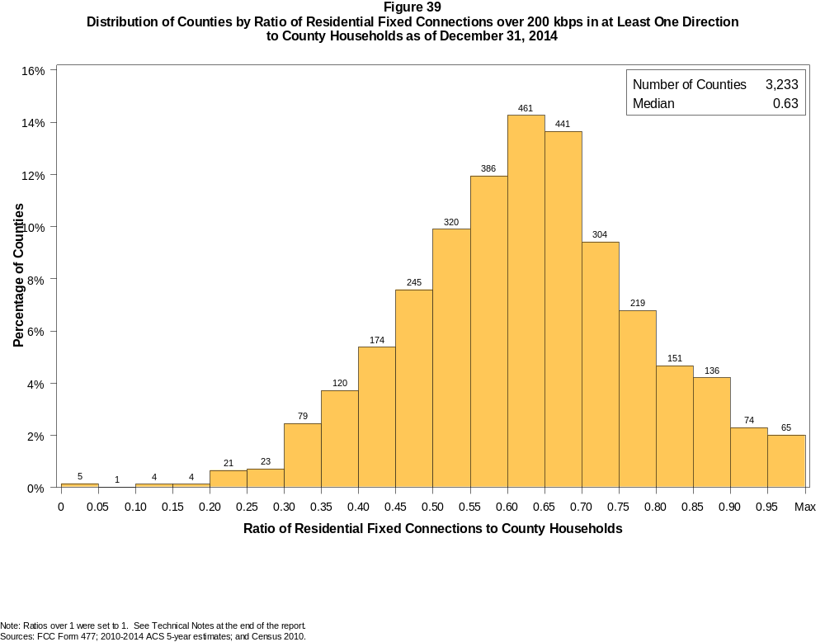

Figure 40
Distribution of Counties by Ratio of Residential Fixed Connections over 200 kbps in at Least One Direction
to County Households by Technology as of December 31, 2014

 | Ratio of Residential Fixed Connections to County Households
Technology | Zero | Greater than 0 and no more than 5% | Greater than 5 and no more than 10% | Greater than 10 and no more than 20% | Greater than 20 and no more than 30% | Greater than 30 and no more than 40% | Greater than 40 and no more than 50% | Greater than 50 and no more than 60% | Greater than 60 and no more than 80% | Greater than 80 and no more than 100% | 100% or more
aDSL | 1.0 | 4.1 | 7.1 | 28.3 | 28.2 | 18.7 | 8.4 | 2.6 | 1.3 | 0.3 | 0.1
sDSL | 81.9 | 17.7 | 0.2 | 0.0 | 0.1 | 0.0 | 0.0 | 0.0 | 0.0 | 0.0 | 0.0
Other Wireline | 90.7 | 8.6 | 0.2 | 0.2 | 0.0 | 0.2 | 0.0 | 0.0 | 0.0 | 0.0 | 0.0
Cable Modem | 12.7 | 7.9 | 7.9 | 16.1 | 15.6 | 14.7 | 12.2 | 8.2 | 4.1 | 0.3 | 0.2
FTTP | 41.6 | 37.1 | 6.8 | 6.2 | 3.1 | 2.1 | 1.6 | 0.8 | 0.8 | 0.0 | 0.0
Satellite | 0.7 | 64.2 | 23.8 | 9.9 | 1.2 | 0.1 | 0.1 | 0.0 | 0.0 | 0.0 | 0.0
Fixed Wireless | 29.3 | 53.6 | 10.0 | 5.4 | 1.2 | 0.5 | 0.1 | 0.0 | 0.0 | 0.0 | 0.0
Total | 0.1 | 0.0 | 0.0 | 0.2 | 1.4 | 6.2 | 13.0 | 21.9 | 44.0 | 11.7 | 1.5

Note: Figures may not sum to totals due to rounding. See Technical Notes at the end of the report.
Sources: FCC Form 477; 2010-2014 ACS 5-year estimates; and Census 2010.

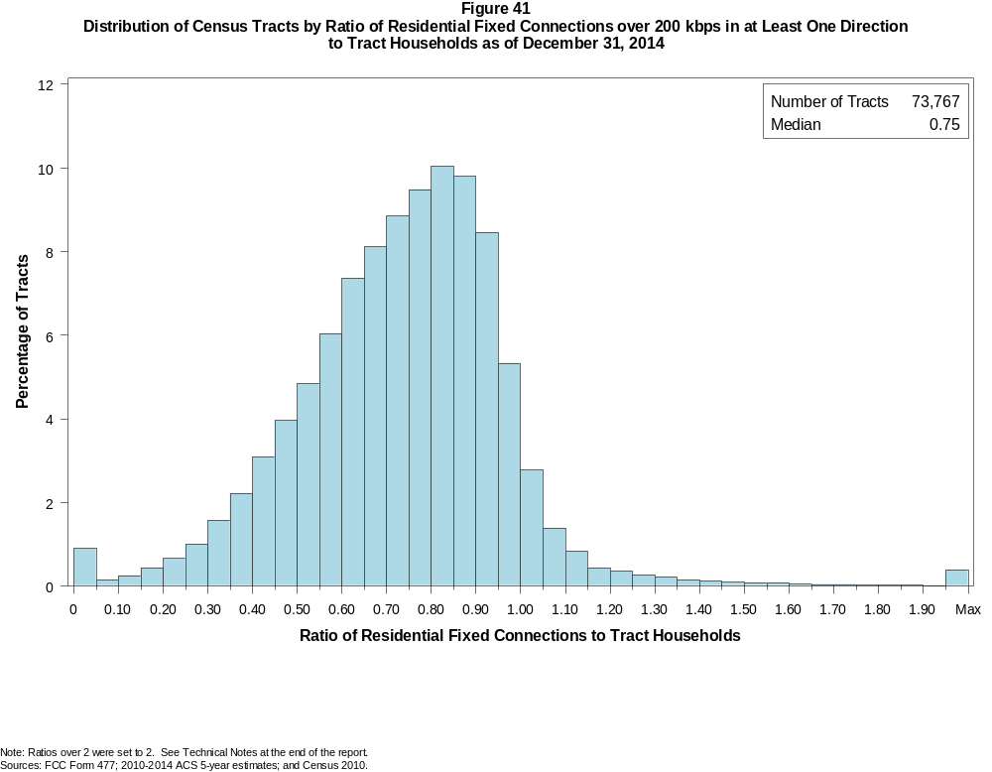

Figure 42
Distribution of Census Tracts by Ratio of Residential Fixed Connections over 200 kbps in at Least One Direction
to Tract Households by Technology as of December 31, 2014

 | Ratio of Residential Fixed Connections to Tract Households
Technology | Zero | Greater than 0 and no more than 5% | Greater than 5 and no more than 10% | Greater than 10 and no more than 20% | Greater than 20 and no more than 30% | Greater than 30 and no more than 40% | Greater than 40 and no more than 50% | Greater than 50 and no more than 60% | Greater than 60 and no more than 80% | Greater than 80 and no more than 100% | 100% or more
aDSL | 1.7 | 13.2 | 12.6 | 25.0 | 21.1 | 14.2 | 7.5 | 2.9 | 1.4 | 0.2 | 0.2
sDSL | 96.5 | 3.4 | 0.0 | 0.0 | 0.0 | 0.0 | 0.0 | 0.0 | 0.0 | 0.0 | 0.0
Other Wireline | 98.8 | 1.0 | 0.1 | 0.1 | 0.0 | 0.0 | 0.0 | 0.0 | 0.0 | 0.0 | 0.0
Cable Modem | 5.2 | 3.2 | 2.3 | 5.9 | 11.3 | 16.6 | 18.5 | 16.0 | 16.5 | 3.4 | 1.2
FTTP | 64.4 | 14.6 | 2.8 | 3.9 | 3.2 | 3.4 | 3.6 | 2.3 | 1.5 | 0.2 | 0.1
Satellite | 24.8 | 65.2 | 5.4 | 3.3 | 0.8 | 0.2 | 0.1 | 0.0 | 0.0 | 0.0 | 0.0
Fixed Wireless | 77.1 | 18.1 | 2.3 | 1.7 | 0.5 | 0.2 | 0.1 | 0.0 | 0.0 | 0.0 | 0.0
Total | 0.8 | 0.1 | 0.2 | 0.7 | 1.7 | 3.8 | 7.1 | 10.9 | 33.8 | 33.6 | 7.4

Note: Figures may not sum to totals due to rounding. See Technical Notes at the end of the report.
Sources: FCC Form 477; 2010-2014 ACS 5-year estimates; and Census 2010.

Figure 43
Percentage of Developed Census Blocks with Residential Fixed Connections by Technology as of December 31, 2014
(Connections over 200 kbps in at least one direction)

 | Number of Providers
Technology | Zero | One | Two | Three | Four | Five | Six | Seven or More
aDSL | 27.5 | 68.9 | 3.4 | 0.1 | 0.0 | 0.0 | 0.0 | 0.0
sDSL | 98.8 | 1.2 | 0.0 | 0.0 | 0.0 | 0.0 | 0.0 | 0.0
Other Wireline | 96.3 | 3.7 | 0.0 | 0.0 | 0.0 | 0.0 | 0.0 | 0.0
Cable Modem | 33.9 | 62.3 | 3.6 | 0.3 | 0.0 | 0.0 | 0.0 | 0.0
FTTP | 85.0 | 14.5 | 0.5 | 0.0 | 0.0 | 0.0 | 0.0 | 0.0
Satellite | 0.0 | 1.1 | 58.5 | 40.3 | 0.0 | 0.0 | 0.0 | 0.0
Fixed Wireless | 61.2 | 26.4 | 8.8 | 3.1 | 0.5 | 0.0 | 0.0 | 0.0
Power Line | 100.0 | 0.0 | 0.0 | 0.0 | 0.0 | 0.0 | 0.0 | 0.0
aDSL and/or Cable Modem and/or FTTP | 15.2 | 24.3 | 52.6 | 7.2 | 0.7 | 0.0 | 0.0 | 0.0
Any Technology | 0.0 | 0.2 | 4.4 | 15.1 | 33.6 | 29.2 | 12.3 | 5.2

Note: Figures may not sum to totals due to rounding. The number of providers in a census tract does not necessarily reflect the number of choices available to a particular household, and does not purport
to measure competition. Developed census blocks are those with housing units based on the 2010 census.
Sources: FCC Form 477 and Census 2010.

Figure 44
Distribution of Counties by Ratio of Residential Fixed Connections to County Households by State as of December 31, 2014
(Connections over 200 kbps in at least one direction)

 |  | Ratio of Residential Fixed Connections over 200 kbps in at Least One Direction to County Households
State | Counties | Zero | Greater than 0 and no more than 5% | Greater than 5 and no more than 10% | Greater than 10 and no more than 20% | Greater than 20 and no more than 30% | Greater than 30 and no more than 40% | Greater than 40 and no more than 50% | Greater than 50 and no more than 60% | Greater than 60 and no more than 80% | Greater than 80 and no more than 100% | 100% or more
Alabama | 67 | 0 | 0 | 0 | 0 | 1 | 8 | 19 | 19 | 16 | 4 | 0
Alaska | 29 | 0 | 0 | 0 | 0 | 1 | 3 | 4 | 6 | 9 | 5 | 1
American Samoa | 5 | 3 | 0 | 1 | 0 | 1 | 0 | 0 | 0 | 0 | 0 | 0
Arizona | 15 | 0 | 0 | 0 | 0 | 0 | 0 | 2 | 0 | 12 | 1 | 0
Arkansas | 75 | 0 | 0 | 0 | 0 | 1 | 12 | 30 | 16 | 15 | 1 | 0
California | 58 | 0 | 0 | 0 | 0 | 0 | 1 | 0 | 5 | 28 | 23 | 1
Colorado | 64 | 0 | 0 | 0 | 0 | 0 | 1 | 4 | 10 | 24 | 15 | 10
Connecticut | 8 | 0 | 0 | 0 | 0 | 0 | 0 | 0 | 0 | 5 | 3 | 0
Delaware | 3 | 0 | 0 | 0 | 0 | 0 | 0 | 0 | 0 | 0 | 3 | 0
District of Columbia | 1 | 0 | 0 | 0 | 0 | 0 | 0 | 0 | 0 | 0 | 1 | 0
Florida | 67 | 0 | 0 | 0 | 0 | 0 | 1 | 2 | 16 | 12 | 29 | 7
Georgia | 159 | 0 | 0 | 0 | 1 | 5 | 14 | 30 | 43 | 43 | 21 | 2
Guam | 1 | 0 | 0 | 0 | 0 | 0 | 0 | 0 | 0 | 0 | 1 | 0
Hawaii | 5 | 0 | 1 | 0 | 0 | 0 | 0 | 0 | 0 | 1 | 3 | 0
Idaho | 44 | 0 | 0 | 0 | 0 | 0 | 3 | 7 | 9 | 19 | 5 | 1
Illinois | 102 | 0 | 0 | 0 | 1 | 3 | 5 | 12 | 25 | 49 | 7 | 0
Indiana | 92 | 0 | 0 | 0 | 0 | 0 | 1 | 9 | 27 | 49 | 6 | 0
Iowa | 99 | 0 | 0 | 0 | 0 | 0 | 0 | 1 | 19 | 75 | 4 | 0
Kansas | 105 | 0 | 0 | 0 | 0 | 0 | 3 | 8 | 21 | 62 | 11 | 0
Kentucky | 120 | 0 | 0 | 0 | 1 | 1 | 4 | 20 | 42 | 45 | 4 | 3
Louisiana | 64 | 0 | 0 | 0 | 0 | 1 | 8 | 12 | 16 | 25 | 2 | 0
Maine | 16 | 0 | 0 | 0 | 0 | 0 | 0 | 0 | 1 | 7 | 8 | 0
Maryland | 24 | 0 | 0 | 0 | 0 | 0 | 0 | 2 | 5 | 9 | 7 | 1
Massachusetts | 14 | 0 | 0 | 0 | 0 | 0 | 0 | 0 | 0 | 5 | 6 | 3
Michigan | 83 | 0 | 0 | 0 | 0 | 0 | 1 | 7 | 24 | 43 | 8 | 0
Minnesota | 87 | 0 | 0 | 0 | 0 | 0 | 6 | 4 | 15 | 55 | 7 | 0
Mississippi | 82 | 0 | 0 | 0 | 3 | 8 | 28 | 23 | 9 | 10 | 1 | 0
Missouri | 115 | 0 | 0 | 0 | 0 | 1 | 7 | 22 | 42 | 38 | 5 | 0
Montana | 56 | 0 | 0 | 0 | 0 | 0 | 1 | 1 | 8 | 39 | 7 | 0
Nebraska | 93 | 0 | 0 | 0 | 0 | 0 | 6 | 16 | 19 | 45 | 5 | 2

Figure 44 - Continued
Distribution of Counties by Ratio of Residential Fixed Connections to County Households by State as of December 31, 2014
(Connections over 200 kbps in at least one direction)

 |  | Ratio of Residential Fixed Connections over 200 kbps in at Least One Direction to County Households
State | Counties | Zero | Greater than 0 and no more than 5% | Greater than 5 and no more than 10% | Greater than 10 and no more than 20% | Greater than 20 and no more than 30% | Greater than 30 and no more than 40% | Greater than 40 and no more than 50% | Greater than 50 and no more than 60% | Greater than 60 and no more than 80% | Greater than 80 and no more than 100% | 100% or more
Nevada | 17 | 0 | 0 | 0 | 0 | 0 | 2 | 2 | 4 | 7 | 2 | 0
New Hampshire | 10 | 0 | 0 | 0 | 0 | 0 | 0 | 0 | 0 | 2 | 8 | 0
New Jersey | 21 | 0 | 0 | 0 | 0 | 0 | 0 | 0 | 0 | 4 | 16 | 1
New Mexico | 33 | 0 | 0 | 0 | 0 | 0 | 1 | 4 | 8 | 17 | 3 | 0
New York | 62 | 0 | 0 | 0 | 0 | 0 | 0 | 0 | 9 | 39 | 12 | 2
North Carolina | 100 | 0 | 0 | 0 | 0 | 0 | 1 | 11 | 20 | 53 | 13 | 2
North Dakota | 53 | 0 | 0 | 0 | 0 | 0 | 0 | 2 | 6 | 35 | 10 | 0
Northern Mariana Isl | 4 | 1 | 0 | 0 | 0 | 0 | 2 | 1 | 0 | 0 | 0 | 0
Ohio | 88 | 0 | 0 | 0 | 0 | 0 | 5 | 2 | 19 | 58 | 4 | 0
Oklahoma | 77 | 0 | 0 | 0 | 0 | 2 | 8 | 18 | 20 | 27 | 2 | 0
Oregon | 36 | 0 | 0 | 0 | 0 | 0 | 0 | 1 | 8 | 21 | 6 | 0
Pennsylvania | 67 | 0 | 0 | 0 | 0 | 1 | 2 | 4 | 11 | 36 | 12 | 1
Puerto Rico | 78 | 0 | 0 | 0 | 0 | 12 | 12 | 32 | 18 | 3 | 1 | 0
Rhode Island | 5 | 0 | 0 | 0 | 0 | 0 | 0 | 0 | 0 | 2 | 3 | 0
South Carolina | 46 | 0 | 0 | 0 | 0 | 0 | 5 | 9 | 9 | 19 | 3 | 1
South Dakota | 66 | 0 | 0 | 0 | 0 | 0 | 1 | 4 | 10 | 46 | 5 | 0
Tennessee | 95 | 0 | 0 | 0 | 0 | 2 | 8 | 15 | 36 | 32 | 1 | 1
Texas | 254 | 0 | 0 | 0 | 0 | 1 | 19 | 48 | 78 | 90 | 17 | 1
Utah | 29 | 0 | 0 | 0 | 0 | 0 | 0 | 4 | 1 | 13 | 8 | 3
Vermont | 14 | 0 | 0 | 0 | 0 | 0 | 0 | 0 | 0 | 7 | 7 | 0
Virgin Islands | 3 | 0 | 0 | 0 | 0 | 0 | 2 | 0 | 0 | 1 | 0 | 0
Virginia | 133 | 0 | 0 | 0 | 1 | 3 | 14 | 19 | 21 | 49 | 23 | 3
Washington | 39 | 0 | 0 | 0 | 0 | 0 | 1 | 1 | 3 | 23 | 10 | 1
West Virginia | 55 | 0 | 0 | 0 | 1 | 0 | 3 | 6 | 19 | 25 | 1 | 0
Wisconsin | 72 | 0 | 0 | 0 | 0 | 0 | 0 | 2 | 8 | 56 | 6 | 0
Wyoming | 23 | 0 | 0 | 0 | 0 | 0 | 0 | 1 | 3 | 16 | 2 | 1
Total | 3,233 | 4 | 1 | 1 | 8 | 44 | 199 | 421 | 708 | 1421 | 378 | 48

Note: Figures may not sum to totals due to rounding. See Technical Notes at the end of the report.
Sources: FCC Form 477; 2010-2014 ACS 5-year estimates (Households for U.S. and District of Columbia); Census 2010 (Households for Puerto Rico, American Samoa,
Guam, Northern Mariana Islands and U.S. Virgin Islands).

Figure 45
Distribution of Census Tracts by Ratio of Residential Fixed Connections to Tract Households by State as of December 31, 2014
(Connections over 200 kbps in at least one direction)

 |  | Ratio of Residential Fixed Connections over 200 kbps in at Least One Direction to Tract Households
State | Tracts | Zero | Greater than 0 and no more than 5% | Greater than 5 and no more than 10% | Greater than 10 and no more than 20% | Greater than 20 and no more than 30% | Greater than 30 and no more than 40% | Greater than 40 and no more than 50% | Greater than 50 and no more than 60% | Greater than 60 and no more than 80% | Greater than 80 and no more than 100% | 100% or more
Alabama | 1,179 | 4 | 1 | 1 | 4 | 47 | 109 | 205 | 230 | 369 | 163 | 46
Alaska | 167 | 1 | 0 | 0 | 2 | 7 | 7 | 7 | 9 | 57 | 67 | 10
American Samoa | 18 | 3 | 6 | 2 | 4 | 1 | 0 | 0 | 1 | 0 | 1 | 0
Arizona | 1,526 | 26 | 5 | 11 | 5 | 20 | 42 | 79 | 152 | 384 | 565 | 237
Arkansas | 686 | 2 | 1 | 0 | 11 | 36 | 78 | 144 | 122 | 187 | 90 | 15
California | 8,036 | 54 | 4 | 7 | 12 | 52 | 95 | 270 | 537 | 2,298 | 4,018 | 689
Colorado | 1,249 | 14 | 0 | 0 | 0 | 4 | 8 | 28 | 69 | 383 | 569 | 174
Connecticut | 829 | 2 | 0 | 0 | 0 | 0 | 7 | 32 | 66 | 298 | 386 | 38
Delaware | 215 | 1 | 0 | 0 | 0 | 1 | 0 | 4 | 13 | 57 | 101 | 38
District of Columbia | 179 | 3 | 0 | 0 | 0 | 0 | 0 | 8 | 21 | 70 | 52 | 25
Florida | 4,199 | 38 | 1 | 2 | 13 | 32 | 57 | 126 | 236 | 1,138 | 1,757 | 799
Georgia | 1,964 | 10 | 1 | 3 | 10 | 40 | 112 | 195 | 272 | 612 | 590 | 119
Guam | 56 | 5 | 1 | 0 | 8 | 3 | 2 | 4 | 5 | 9 | 4 | 15
Hawaii | 326 | 12 | 1 | 0 | 4 | 4 | 4 | 9 | 15 | 94 | 141 | 42
Idaho | 298 | 1 | 0 | 1 | 0 | 5 | 15 | 21 | 40 | 134 | 67 | 14
Illinois | 3,121 | 7 | 4 | 5 | 10 | 36 | 113 | 269 | 404 | 1,181 | 1,012 | 80
Indiana | 1,508 | 5 | 2 | 0 | 4 | 25 | 74 | 168 | 298 | 607 | 288 | 37
Iowa | 825 | 3 | 0 | 1 | 0 | 0 | 6 | 40 | 138 | 502 | 118 | 17
Kansas | 770 | 10 | 0 | 0 | 6 | 3 | 19 | 60 | 140 | 304 | 196 | 32
Kentucky | 1,115 | 9 | 0 | 4 | 14 | 19 | 69 | 139 | 207 | 412 | 207 | 35
Louisiana | 1,136 | 11 | 1 | 1 | 3 | 37 | 101 | 150 | 196 | 394 | 206 | 36
Maine | 351 | 0 | 0 | 0 | 0 | 3 | 3 | 7 | 29 | 177 | 112 | 20
Maryland | 1,394 | 8 | 0 | 0 | 6 | 9 | 41 | 84 | 88 | 340 | 695 | 123
Massachusetts | 1,471 | 13 | 0 | 1 | 1 | 1 | 8 | 16 | 45 | 418 | 832 | 136
Michigan | 2,767 | 31 | 0 | 1 | 19 | 66 | 169 | 249 | 323 | 975 | 870 | 64
Minnesota | 1,335 | 4 | 1 | 1 | 15 | 11 | 44 | 62 | 137 | 592 | 435 | 33
Mississippi | 661 | 4 | 1 | 2 | 20 | 60 | 140 | 122 | 95 | 149 | 57 | 11
Missouri | 1,393 | 5 | 0 | 0 | 10 | 21 | 103 | 165 | 231 | 481 | 333 | 44
Montana | 271 | 2 | 1 | 1 | 1 | 1 | 3 | 12 | 29 | 134 | 74 | 13
Nebraska | 532 | 3 | 0 | 0 | 1 | 5 | 10 | 36 | 82 | 249 | 99 | 47

Figure 45 - Continued
Distribution of Census Tracts by Ratio of Residential Fixed Connections to Tract Households by State as of December 31, 2014
(Connections over 200 kbps in at least one direction)

 |  | Ratio of Residential Fixed Connections over 200 kbps in at Least One Direction to Tract Households
State | Tracts | Zero | Greater than 0 and no more than 5% | Greater than 5 and no more than 10% | Greater than 10 and no more than 20% | Greater than 20 and no more than 30% | Greater than 30 and no more than 40% | Greater than 40 and no more than 50% | Greater than 50 and no more than 60% | Greater than 60 and no more than 80% | Greater than 80 and no more than 100% | 100% or more
Nevada | 683 | 5 | 0 | 1 | 2 | 9 | 23 | 35 | 70 | 211 | 257 | 70
New Hampshire | 294 | 2 | 0 | 0 | 0 | 1 | 0 | 1 | 4 | 74 | 190 | 22
New Jersey | 2,004 | 10 | 0 | 0 | 1 | 3 | 5 | 7 | 55 | 520 | 1,144 | 259
New Mexico | 499 | 4 | 3 | 2 | 10 | 8 | 22 | 53 | 85 | 190 | 101 | 21
New York | 4,900 | 89 | 0 | 3 | 18 | 20 | 53 | 138 | 301 | 1,880 | 1,858 | 540
North Carolina | 2,183 | 19 | 2 | 1 | 4 | 20 | 74 | 225 | 332 | 830 | 541 | 135
North Dakota | 205 | 0 | 1 | 0 | 0 | 1 | 1 | 10 | 15 | 107 | 55 | 15
Northern Mariana Isl | 22 | 2 | 0 | 0 | 1 | 3 | 5 | 7 | 1 | 3 | 0 | 0
Ohio | 2,946 | 7 | 0 | 1 | 21 | 82 | 140 | 259 | 388 | 1,180 | 794 | 74
Oklahoma | 1,046 | 2 | 2 | 3 | 15 | 46 | 85 | 147 | 177 | 325 | 185 | 59
Oregon | 827 | 2 | 6 | 1 | 2 | 5 | 4 | 50 | 104 | 399 | 217 | 37
Pennsylvania | 3,217 | 26 | 0 | 4 | 40 | 73 | 52 | 159 | 315 | 1,296 | 1,060 | 192
Puerto Rico | 903 | 24 | 28 | 35 | 130 | 143 | 145 | 109 | 93 | 80 | 43 | 73
Rhode Island | 241 | 1 | 0 | 0 | 0 | 0 | 0 | 1 | 5 | 108 | 116 | 10
South Carolina | 1,097 | 10 | 0 | 0 | 4 | 21 | 85 | 145 | 180 | 338 | 239 | 75
South Dakota | 222 | 0 | 1 | 0 | 0 | 1 | 4 | 6 | 22 | 135 | 46 | 7
Tennessee | 1,497 | 22 | 1 | 3 | 11 | 42 | 125 | 203 | 273 | 509 | 264 | 44
Texas | 5,253 | 39 | 0 | 7 | 44 | 136 | 369 | 638 | 765 | 1,469 | 1,373 | 413
Utah | 588 | 4 | 1 | 3 | 1 | 1 | 5 | 8 | 23 | 177 | 302 | 63
Vermont | 184 | 1 | 0 | 0 | 0 | 0 | 0 | 1 | 7 | 86 | 70 | 19
Virgin Islands | 29 | 0 | 0 | 1 | 3 | 6 | 5 | 7 | 4 | 1 | 1 | 1
Virginia | 1,895 | 24 | 0 | 0 | 8 | 40 | 87 | 121 | 200 | 431 | 763 | 221
Washington | 1,446 | 3 | 1 | 1 | 1 | 7 | 16 | 38 | 86 | 548 | 657 | 88
West Virginia | 484 | 0 | 1 | 3 | 8 | 16 | 27 | 55 | 79 | 211 | 66 | 18
Wisconsin | 1,393 | 3 | 1 | 0 | 3 | 1 | 33 | 83 | 180 | 740 | 329 | 20
Wyoming | 132 | 1 | 0 | 0 | 0 | 1 | 2 | 5 | 12 | 65 | 43 | 3
Total | 73,767 | 591 | 79 | 113 | 510 | 1,235 | 2,806 | 5,222 | 8,006 | 24,918 | 24,819 | 5,468

Note: Figures may not sum to totals due to rounding. See Technical Notes at the end of the report.
Sources: FCC Form 477; 2010-2014 ACS 5-year estimates (Households for U.S. and District of Columbia); Census 2010 (Households for Puerto Rico, American Samoa,
Guam, Northern Mariana Islands and U.S. Virgin Islands).

